Park Estate School

New Enrolment Scheme

Overview – what is happening?
Enrolment schemes are implemented when new schools are established in a community. The Ministry of Education is developing an enrolment scheme for Park Estate School, which will be in effect for when the new school opens in 2022. Having an enrolment scheme in place will ensure the Board of Trustees has a fair and transparent mechanism to manage the roll as it grows. Like many new schools, Park Estate School is in a greenfields area of growth, and it’s important that local students have access to their local school.
The new enrolment scheme for Park Estate School will have a home zone, like other schools with enrolment schemes in the area. Children that live within this area will have entitlement to enrol at Park Estate School. The home zone area is shown on the map below and here includes:

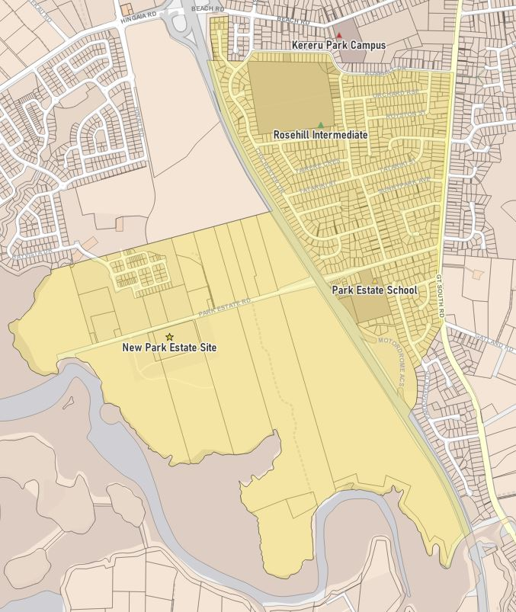
Starting at the corner of Rosehill Drive and Gt South Road, travel south down Gt South Road until 499 Gt South Road (only odd numbers included). Continue southwest to 71 Parkhaven Drive, including odd numbers from 1-71 and even numbers from 2-28. The eastern boundary then continues southwest to the Southern Motorway, travelling south until the end of 144 Park Estate Road. The southern boundary then travels along the coastline, including the area south of Park Estate Road and north of Park Estate Road until 44 Ngakoro Road (including Tuangi Road, Matarau Road, Nohoanga Road, Pahekeheke Road, Papareia Road, Rauaruhe Road, Te Aute Road, Papakowhatu Road, Horomia Road). Then continue north along the Southern Motorway until shifting east to Dumas Place. Include all of Dumas Place and turn northeast at the intersection of Chichester Drive and Dumas Place until Rosehill Drive, including 18 Chichester Drive and above. Continue east along Rosehill Drive until Gt South Road (only even numbers included)

What does this mean for my family?
If you live in enrolment scheme home area for Park Estate School, you will be entitled to enrol your child at the new school. This entitlement applies to new students starting school, as well as any primary school aged children currently attending another school in the area.
Families who live outside the enrolment scheme home zone of Park Estate School do not have entitlement to enrol and could only attend if the Board of Trustees planned to enrol any out of zone enrolments. The enrolment scheme will establish the process for this, and places will only be available if the Board considers it has the capacity to allow for this. Further information about whether any out of zone places will be made available will be made later in 2021.

Consultation process and timeline
The Ministry of Education is currently undertaking consultation about the proposed changes and new enrolment schemes. You can have your say by:
- Completing the survey at https://consultation.education.govt.nz/education/Park-estate-schools-enrolment-scheme
- Emailing auckland.EnrolmentSchemes@education.govt.nz if you have further questions or comments.
Consultation will run from Monday 17th May, until 18th of June. The Ministry will consider all feedback and liaise with the Park Estate School Board of Trustees before making a final decision. We expect the community to be updated about progress made about mid-Term 2. The new schemes and changes will come into effect for the beginning of 2022.

