Portland School

New Enrolment Scheme

Overview – what is changing?
The Ministry of Education regularly monitors enrolment patterns, population growth and anticipated school roll changes across the Whangarei district. As part of this monitoring and regular review, we now consider an enrolment scheme is necessary for Portland School. This is due to growth of the school roll and because we need to ensure the Board has a fair and transparent mechanism to manage the roll. It also means we can ensure we are making best use of educational facilities across the wider Whangarei area.
The new enrolment scheme will have a home zone, like other schools with enrolment schemes in the area. Children that live within this area will have entitlement to enrol at Portland School. The home zone area is shown on the map below and described here:
PORTLAND SCHOOL (#1084)
Proposed Draft Enrolment Scheme
Commencement date: 14 October 2024

The guidelines for development and operation of enrolment schemes are issued under Schedule 20, Clause 3 (3) of the Education and Training Act 2020 for the purpose of describing the basis on which the Secretary’s powers in relation to enrolment schemes will be exercised.
Home Zone
All students who live within the home zone described below shall be eligible to enrol at the school.
The Home Zone includes addresses on both sides of the boundary roads mentioned in the description, and all no-exit roads off the boundary roads are included in the zone unless otherwise stated.
The zone starts at 86 Portland Road and travels east along Portland Road to include all Portland Road addresses up to the intersection with Manaia Road and Tikorangi Road. Addresses on Portland Quarry Road, Old Stone Road, and Atkins Road are in-zone. The zone continues south along Manaia Road to the McGill Road intersection and includes Tikorangi Road and Railway Road addresses. The zone travels south and then west and then south along McGill Road as far as number 307 McGill Road. All addresses on Portland Wharf Road and Manaia Road are in-zone. The zone includes addresses on Marusumi Road.

Section 75 of the Education and Training Act 2020 states that

“the Secretary may authorise an enrolment scheme to permit a student to enrol at the school as if the student lived in the home zone of the school if, -

(b) in the case of a new enrolment scheme, the student,

1. lives outside of the home zone of the new enrolment scheme; and
2. has a sibling who is enrolled at the school at the time that the new enrolment scheme is implemented.”

Special Programmes
This priority category is not applicable at this school because the school does not run a Special programme approved by the Secretary.
Out of Zone Enrolments
Each year the Board of Trustees will determine the number of places which are likely to be available in the following year for the enrolment of students who live outside the home zone. The Board will publish this information by public notice in a medium appropriate to the area served by the school. The notice will indicate how applications are to be made and will specify a date by which all applications must be received.
Applications for enrolments will be processed in the following order of priority:
First Priority This priority is not applicable at this school because the school does not run a special programme approved by the Secretary for Education.
Second Priority will be given to applicants who are siblings of current students.
Third Priority will be given to applicants who are siblings of former students.
Fourth Priority will be given to any applicant who is a child of a former student of the school.
Fifth Priority will be given to any applicant who is either a child of an employee of the board of the school or a child of a member of the board of the school.
Sixth Priority will be given to all other applicants.

If there are more applicants in the second, third, fourth, fifth or sixth priority groups than there are places available, selection within the priority group will be by ballot conducted in accordance with instructions by the Secretary, under Schedule 20, Clause 3 (1) of the Education and Training Act 2020. Parents will be informed of the date of any ballot by public notice in a medium appropriate to the area served by the school.
Applicants seeking second or third priority status may be required to give proof of a sibling relationship.

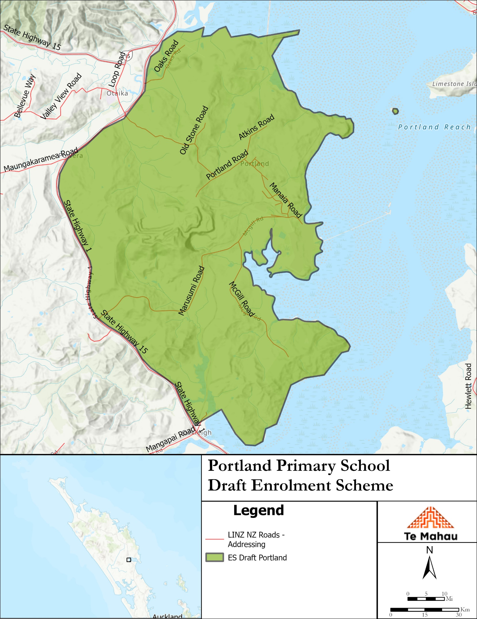

What does this mean for my family?
Any student currently enrolled at Portland School will not be impacted by the new enrolment scheme. All students enrolled (and attending school) will be entitled to continue attending Portland School, irrespective of where they currently live.
The establishment of the enrolment scheme and home zone will affect all enrolments starting at the beginning of Term 4 2024. This includes current families who have a younger sibling looking to enrol at Portland School starting on 14 October 2024 (the commencement date) or later. The flowchart below will help you assess your indicative eligibility to enrol after the commencement date.
Does your child (enrolling in Term 4 2024 or later) live within the enrolment scheme home zone? (check map for reference)
In zone enrolment
YES

NO
Out of zone enrolment
(if places available)

YES
Does your child (enrolling in Term 4 2024 or later) live outside of the zone?

Consultation process and timeline
The Ministry of Education is currently undertaking consultation about the proposed changes and new enrolment schemes. You can have your say by:
Completing the survey at: https://consultation.education.govt.nz/education/portland-school on the Portland School Consultation page.

- This site also has further information about the proposed scheme.
- Emailing taitokerau.enrolmentschemes@education.govt.nz if you have further questions or comments.
Consultation will run 27 May 2024 to 6 July 2024. The Ministry will consider all feedback and liaise with the Portland School Board before making a final decision. We expect the school community to be updated about progress made 30 July 2024. The new scheme and changes will come into effect for enrolments after the commencement date.

