Tuakau School

New Enrolment Scheme

Overview – what is happening?

The Ministry of Education is developing an enrolment scheme for Tuakau School, which will be in effect for the beginning of term 1 in 2024. Having an enrolment scheme in place will ensure the School Board has a fair and transparent mechanism to manage the roll as it grows. Children that live within this area will have entitlement to enrol at Tuakau School. The home zone area is shown on the map on the next page.
The school will also be applying to formalise special programmes for bi-lingual education and learning support as part of the enrolment scheme.
All students who live within the home zone described below and/or shown on the attached map shall be entitled to enrol at the school.
Starting at the intersection of River Road and Alder Road, travel north along River Road (odd addresses 2575-2817, even addresses 2570-2758 included) to Dromgools Road. Turn West along Dromgools Road and continue onto Geraghtys Road and to Buckland Road. Travel northwest along Buckland Road, Tuakau (2392, 2339 and below included) to 2289 Buckland Road and travel cross country north to the railway line. Follow the railway line southeast to Bollard Road. Follow Bollard Road (104, 43 and below included; 12 Park Avenue included) southeast to Whangarata Road. From Whangarata Road (150, 141 and below included) travel cross country to the Waikato River. Travel west along the Waikato River back to the starting point.
All residential addresses on included sides of boundary roads and all no exit roads off included sides of boundary roads are included in the zone unless otherwise stated.
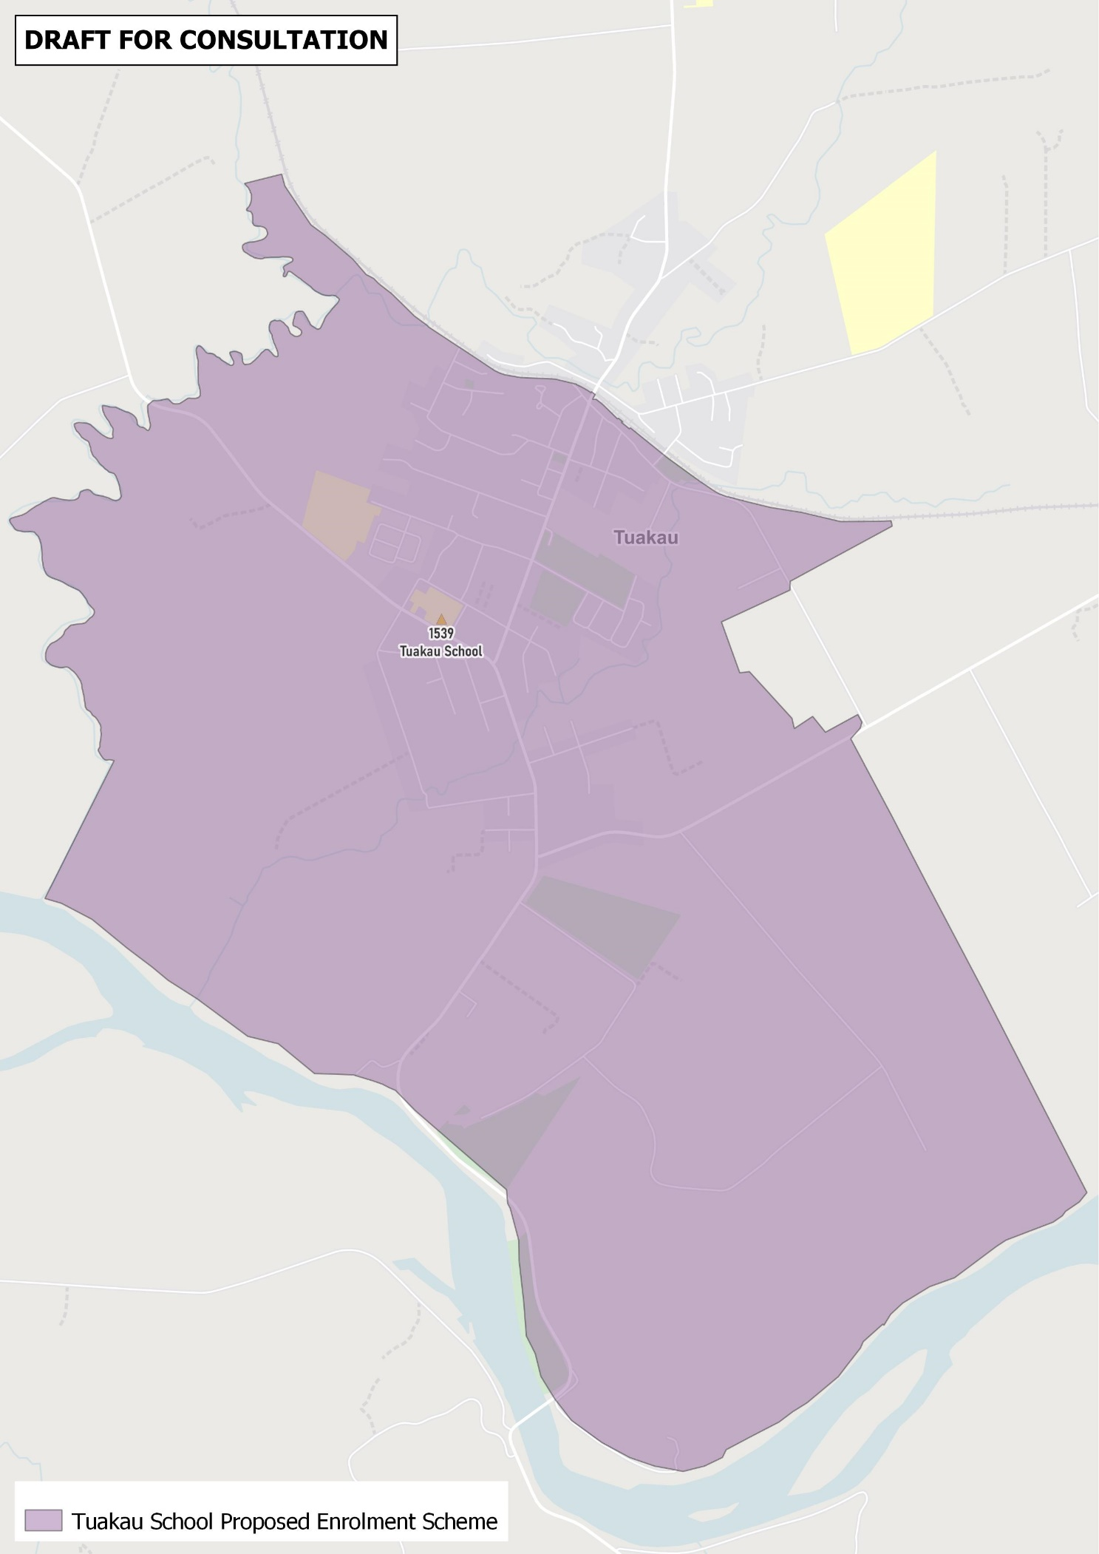

What does this mean for my family?
If you live in enrolment scheme home area for Tuakau School, you will be entitled to enrol your child at the school. This entitlement applies to new students starting school, as well as any students currently attending another school in the area.
Families who live outside the enrolment scheme home zone of Tuakau School do not have entitlement to enrol and could only attend if the School Board planned to enrol any out of zone students. The enrolment scheme will establish the process for this, and places will only be available if the School Board considers it has the capacity to allow for this. Further information about whether any out of zone places will be made available later in 2023.

Consultation process and timeline
The Ministry of Education is currently undertaking consultation about the proposed changes and new enrolment schemes. You can have your say by:
- Completing the survey at https://consultation.education.govt.nz/education/tuakau-school-enrolment-scheme
- Emailing auckland.enrolmentschemes@education.govt.nz if you have further questions or comments
Consultation closes 25 August 2023.
The Ministry will consider all feedback and liaise with the Board before making a final decision. We expect the School community to be updated about progress. The new schemes and changes will come into effect for the beginning of term 1 2024.

