Waimahia Intermediate School

Enrolment Scheme

Overview – what is happening?
The Ministry of Education is proposing an enrolment scheme for Waimahia School, which will be in effect for the beginning of term 2 in 2024. Having an enrolment scheme in place will ensure the School Board has a fair and transparent mechanism to manage the roll as it grows. Children that live within this area will have entitlement to enrol at Lincoln Heights School. The home zone area is shown on the map below and includes:
Starting at 257 Roscommon Road, travel south along Roscommon Road (even addresses 254 and above included) to the intersection of Roscommon Road and Weymouth Road. Travel east along Weymouth Road (even addresses 190 and above, and odd addresses 269 and above included) and then travel southeast along the eastern boundary of Mountfort Park and Leabank School towards Dr Pickering Avenue. Travel southeast again along the eastern boundary of James Cook High School towards Mahia Road. From Mahia Road (even addresses 134 and above, and odd addresses 155 and above included) travel east to Innismara Avenue. Following Innismara Avenue towards the coastline continue west along the coastline back to the starting point.
All no exit roads within the boundaries described above are included in the zone unless otherwise stated.

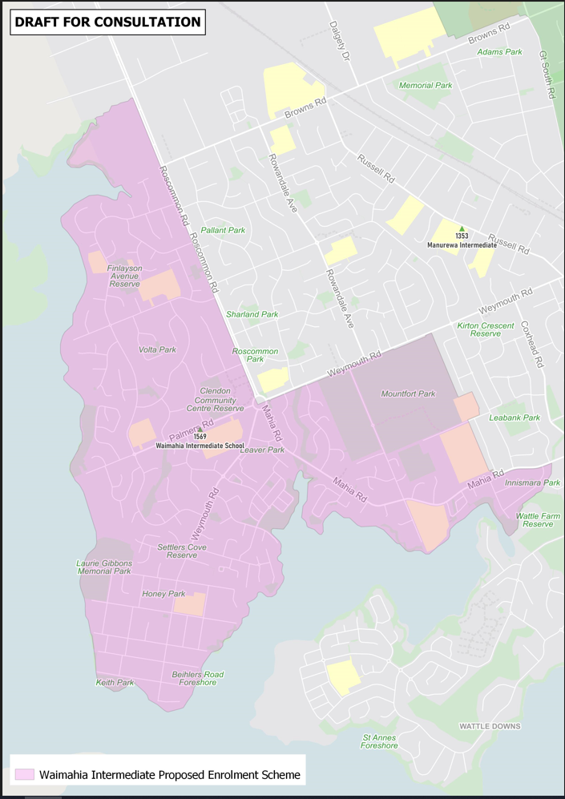

What does this mean for my family?
If you live in the proposed enrolment scheme home area for Waimahia Intermediate School, you will be entitled to enrol your child at the school. This entitlement applies to new students starting school, as well as any intermediate school aged children currently attending another school in the area.
Families who live outside the proposed enrolment scheme home zone do not have entitlement to enrol and could only attend if the school planned to enrol any out of zone students. The enrolment scheme will establish the process for this, and places will only be available if the School Board considers it has the capacity to allow for this. Further information about whether any out of zone places will be made available will be made later in 2023.

Consultation process and timeline
The Ministry of Education is currently undertaking consultation about the proposed changes and new enrolment schemes. You can have your say by:
- https://consultation.education.govt.nz/education/waimahia-intermediate-enrolment-scheme

- Emailing auckland.enrolmentschemes@education.govt.nz if you have further questions or comments.
The Ministry will consider all feedback and liaise with the Board before making a final decision. The new schemes and changes will come into effect for the beginning of Term 2 2024.

