Waiuku College

New Enrolment Scheme

Overview – what is happening?
The Ministry of Education is developing an enrolment scheme for Waiuku College, which will be in effect for the beginning of term 1 in 2022. Having an enrolment scheme in place will ensure the Board of Trustees has a fair and transparent mechanism to manage the roll as it grows. Children that live within this area will have entitlement to enrol at Waiuku College. The home zone area is shown on the map on the next page and includes:
Starting at the intersection of Glenbrook Road and Kingseat Road, travel north along Kingseat Road (odd addresses only) to Mckenzie Road. At that roundabout, follow Puhitahi Creek north until the coastline. Begin travelling west along the coastline and follow the coastline all the way around Seagrove, Clarks Beach, down Taihiki River, Glenbrook Beach, down Waiuku River, up to Manukau Heads, and then south down the western coastline from Manukau Heads to the Waikato River. Follow the Waikato River east until the end of Elbow Road. Travel north along Elbow Road (odd addresses) and then west along Aka Aka Road (odd addresses), then turn north and travel along Eastern Drain Road (west of road included) until it becomes Wily Road. From there, the boundary travels along the eastern edge of Goodwin Road land parcels (all of Goodwin Road included) and then along the western edge of 89C Baldhill Road (163 and above odd, 10 and above even included) until hitting Baldhill Road. Then, travel east along Baldhill Road until turning west up Waiuku Road (odd addresses), turning off at Glenbrook Station Road (odd addresses) until turning off again and heading north along Gearon Road (even addresses until Quinn Road intersection, then both sides of Gearon Road included – from 91A Gearon Road) until Glenbrook Road. At Glenbrook Road travel east, including both side of the road until crossing Taihiki River (down to 913 Glenbrook Road), at which point continue along Glenbrook Road (including only even addresses) until returning to the zone’s origin point at the intersection of Glenbrook Road and Kingseat Road.

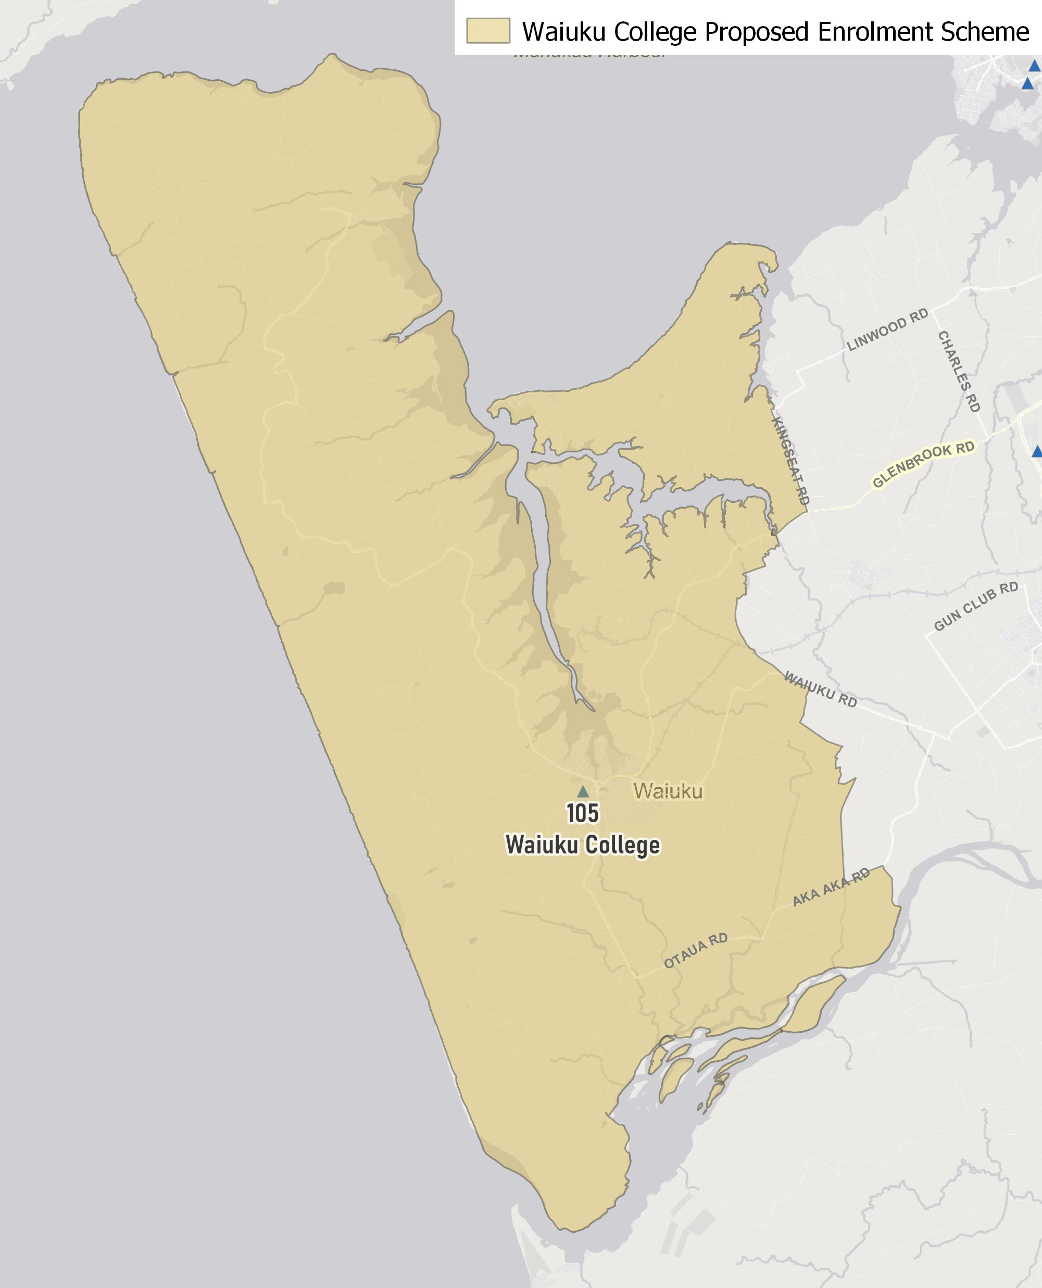

What does this mean for my family?
If you live in enrolment scheme home area for Waiuku College you will be entitled to enrol your child at the school. This entitlement applies to new students starting school, as well as any students currently attending another school in the area.
Families who live outside the enrolment scheme home zone of Waiuku College do not have entitlement to enrol and could only attend if the Board of Trustees planned to enrol any out of zone students. The enrolment scheme will establish the process for this, and places will only be available if the Board of Trustees considers it has the capacity to allow for this. Further information about whether any out of zone places will be made available will be made later in 2021.

Consultation process and timeline
The Ministry of Education is currently undertaking consultation about the proposed changes and new enrolment schemes. You can have your say by:
- Completing the survey at https://consultation.education.govt.nz/education/waiuku-college-enrolment-scheme/
- Emailing auckland.enrolmentschemes@education.govt.nz if you have further questions or comments
The Ministry will consider all feedback and liaise with the Board before making a final decision. We expect the School community to be updated about progress made about mid-Term 3 The new schemes and changes will come into effect for the beginning of 2022.

