Wellsford School

New Enrolment Scheme

Overview – what is happening?
The Ministry of Education is developing an enrolment scheme for Wellsford School, which will be in effect for the beginning of term 1 in 2023. Having an enrolment scheme in place will ensure the Board of Trustees has a fair and transparent mechanism to manage the roll as it grows. Children that live within this area will have entitlement to enrol at Wellsford School. The home zone area is shown on the map on the next page and includes:
Starting at the intersection of Oruawharo road (both sides included) and State Highway 1, travel south along State Highway 1 (even addresses 696-704 only included and odd addresses 701-1189 only included) to Mangawhai Road. Travel east along Mangawhai Road (even addresses 344 and below and odd addresses 341 and below only included; Wharfe Road excluded) to Lower Silver Hill Road (both sides included) and onto Silver Hill Road. Continue east along Silver Hill Road (even addresses 512 and below only included) to Parker Road.
Travel south along Parker Road (both sides included) and across country to Waiteitei Road. Continue south across country from Waiteitei Road (even addresses 334 and below and odd addresses 379A and below only included; Taylor Road included) to Tomarata Valley Road. Travel west along Tomarata Valley Road (odd addresses 169 and below only included) to Whangaripo Valley Road. Travel west along Whangaripo Valley Road (odd addresses 1005 and below and even addresses 1000 and below only included) to Wayby Valley Road. Travel south along Wayby Valley Road (even addresses 564 and below and odd addresses 557 and below only included) to Wilson Road. Travel east along Wilson Road (both sides included) and across country to the intersection of Conical Peak Road (both sides included) and Waiwhiu Road. Travel southwest along Waiwhiu Road (both sides included) to State Highway 1.
Travel north along State Highway 1 to Wayby Station Road. Travel west along Wayby Station Road (both sides included; Oldfield Road included) to Kaipara Coast Highway (SH 16). From Kaipara Coast Highway (odd addresses 5135 and above and even addresses 5150 and above only included) travel across country north to Partridge Road (both sides included) and then north again to J V Grant Road (addresses 141 and below only included). From J V Grant Road, travel northwest across country to Wharehine Road. Travel north along Wharehine Road (addresses 984 and above only included; Pah Hill Road, Beaver Road included; Grice Road excluded) to the coastline of Topuni River. Follow the Topuni River moving east back to the starting point.

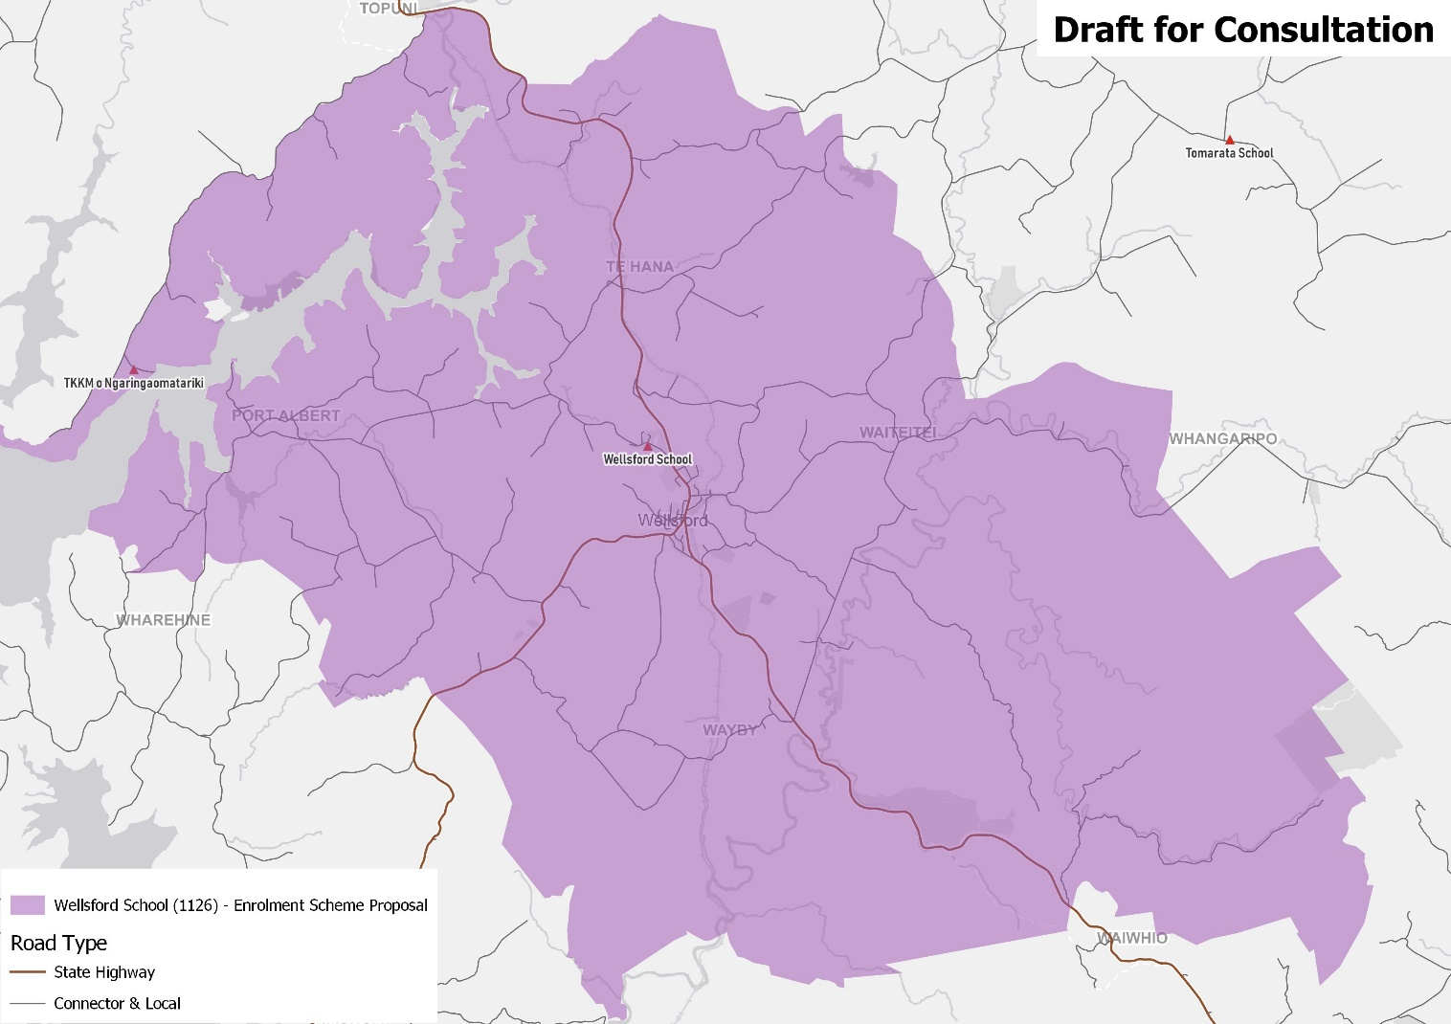

What does this mean for my family?
If you live in enrolment scheme home area for Wellsford School, you will be entitled to enrol your child at the school. This entitlement applies to new students starting school, as well as any students currently attending another school in the area.
Families who live outside the enrolment scheme home zone of Wellsford School do not have entitlement to enrol and could only attend if the Board of Trustees planned to enrol any out of zone students. The enrolment scheme will establish the process for this, and places will only be available if the Board of Trustees considers it has the capacity to allow for this. Further information about whether any out of zone places will be made available will be made later in 2022.

Consultation process and timeline
The Ministry of Education is currently undertaking consultation about the new enrolment scheme. You can have your say by:
- Completing the survey at https://consultation.education.govt.nz/education/wellsford-school-enrolment-scheme
- Emailing auckland.enrolmentschemes@education.govt.nz if you have further questions or comments
The Ministry will consider all feedback and liaise with the Board before making a final decision. We expect the School community to be updated about progress made about mid-Term 3 The new schemes and changes will come into effect for the beginning of 2023.

