Wesley Intermediate School

New Enrolment Scheme

Overview – what is happening?
The Ministry of Education is developing an enrolment scheme for Wesley Intermediate School. Having an enrolment scheme in place will ensure the Board of Trustees has a fair and transparent mechanism to manage the roll as it grows. Children that live within this area will have entitlement to enrol at Wesley Intermediate School. The home zone area is shown on the map on the next page and includes:
Starting at the intersection of New North Road and Richardson Road, travel southeast down Richardson Road (113-223 odd and 104-370 even addresses included, Amazon Parade also included) until turning east down Owairaka Avenue (excluded, Lorraine Avenue and Delphine Close also excluded). At Mt Albert Road (251-305 odd and 258-310 even addresses included, Columbia Road, Huntingtree Avenue, Kiwitea Street 49 and above odd and 66 and above even, and Freyburg Avenue also included), turn southeast and then turn southwest down May Road (excluded). At the Southwestern Motorway (including from south of motorway to Richardson Road until Amazon Parade), turn northwest and travel until New North Road (excluded, Hendon Avenue and Ennismore Road included), turning northwest along New North Road until returning to the origin.

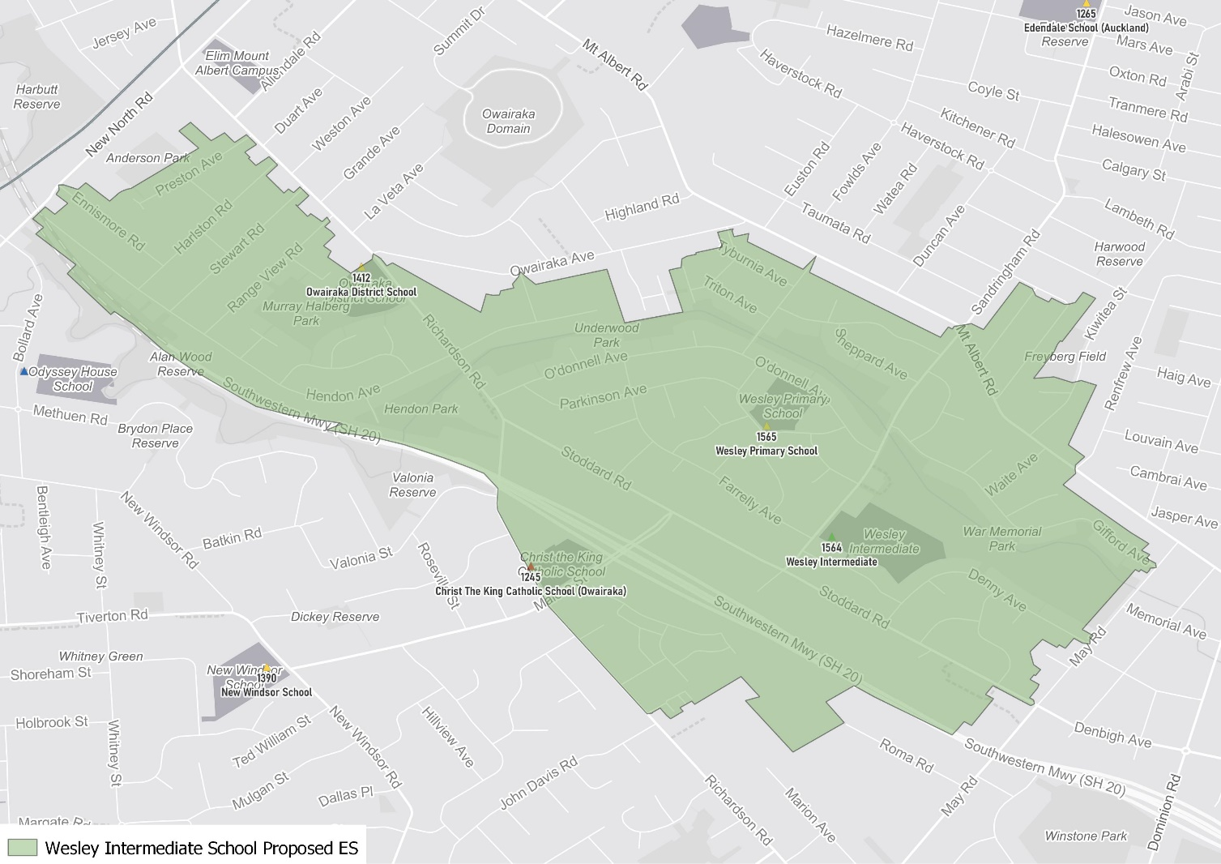

What does this mean for my family?
If you live in enrolment scheme home area for Wesley Intermediate School you will be entitled to enrol your child at the school. This entitlement applies to new students starting school, as well as any intermediate school aged children currently attending another school in the area.
Families who live outside the enrolment scheme home zone of Wesley Intermediate School do not have entitlement to enrol and could only attend if the Board of Trustees planned to enrol any out of zone students. The enrolment scheme will establish the process for this, and places will only be available if the Board of Trustees considers it has the capacity to allow for this. Further information about whether any out of zone places will be made available will be made later in 2021.

Consultation process and timeline
The Ministry of Education is currently undertaking consultation about the proposed changes and new enrolment schemes. You can have your say by:
- Completing the survey at https://consultation.education.govt.nz/education/wesley-intermediate-enrolment-scheme
- Emailing auckland.enrolmentschemes@education.govt.nz if you have further questions or comments
The Ministry will consider all feedback and liaise with the Board before making a final decision. The new schemes and changes will come into effect for the beginning of 2022.

