Whangārei Girls’ High School

New Enrolment Scheme

Overview – what is changing?
The Ministry of Education regularly monitors enrolment patterns, population growth and anticipated school roll changes across the Whangarei district. As part of this monitoring and regular review, we now consider an enrolment scheme is necessary for Whangārei Girls’ High School. This is due to growth of the school roll and because we need to ensure the Board has a fair and transparent mechanism to manage the roll. It also means we can ensure we are making best use of educational facilities across the wider Whangarei area.
The new enrolment scheme will have a home zone, like other schools with enrolment schemes in the area. Children that live within this area will have entitlement to enrol at Whangārei Girls’ High School. The home zone area is shown on the map below and described here:
WHANGĀREI GIRLS’ HIGH SCHOOL (#16)
Proposed Draft Enrolment Scheme
Commencement date: 1 January 2025

The guidelines for development and operation of enrolment schemes are issued under Schedule 20, Clause 3 (3) of the Education and Training Act 2020 for the purpose of describing the basis on which the Secretary’s powers in relation to enrolment schemes will be exercised.
Home Zone

All students who live within the home zone described below (and shown on the attached map) shall be eligible to enrol at the school.

The zone starts at the Kamo Road/Burling Ave intersection and travels east along Burling Ave to Te Rauponga/State Highway 1. Turn north along Te Rauponga/State Highway 1 and turn east just before Puna Rere Drive (not including Puna Rere Drive addresses) to include all addresses along Jack Street, Miro Street and William Jones Drive. From William Jones Drive, turn left onto Rata Place and then onto Rata Lane, and onto Cairnfield Road (Tawa Place and Jane Nelson Place addresses are included). Follow Cairnfield Road to the intersection with Waiatawa Road (all Waiatawa Road addresses are included up to the intersection with Kiripaka Road). The zone continues east from the intersection of Waiatawa Roa and Whareora Road. Millers Lane addresses are included. Travel east along Whareora Road to the intersection with Mt Tiger Road (includes all side roads running off Whareora Road i.e. Clapham Road; Quarry Road; Fantail Lane; Giovanni Drive; Bonetti Rise). Travel south down Mt Tiger Road and continue into Owhiwa Road (all Owhiwa Road addresses are included). From the end of Owhiwa Road to Whangarei Heads Road. From Whangarei Heads Road, turn right onto Taraunui Road and travel north to Telfer Road (to include Rukuwai Road, Lakelands Road, Awa Way and Waiparera Road). From Telfer Road down to the Pataua River mouth. The zone travels south around the coastline of the river mouth and includes the settlement on the south side of the river mouth.

From here the zone follows the coastline from Pataua South to include all settlements from Taiharuru south to Bream Head and around to Whangarei Heads, Parua Bay and Tamaterau. The zone then travels west along Whangarei Heads Road and turns right onto Onerahi Road and includes the Whangarei Airport (Church Street, Weir Crescent and all adjoining streets/roads). The zone travels north along Onerahi Road and across the causeway onto Riverside Drive (with addresses on all adjoining roads/streets included). Follow Riverside Drive along to Victoria Bridge, and then turn right at the roundabout and travel south-east along the Twin Coast Discovery Highway/Dent Street and on to Herekino Street (including all addresses on Reyburn House Lane). At the roundabout, turn right onto Port Road and follow Port Road to Kioreroa Road. All streets and roads in the Port area are included. Follow Kioreroa Road to Rewa Rewa Road and on to Otaika Road/State Highway 1. Turn left and travel south down State Highway 1 to include the Otaika; Puwera; and Oakleigh settlements to Oakleigh Rise.

From here the zone stops and turns north to include Maungakaramea Road from the intersection with State Highway 1 to number 169 Maungakaramea Road. Follow State Highway 1 north to Loop Road. Turn left on Loop Road and turn right on Otaika Valley Road/State Highway 15. Includes all addresses on Valley View Road and adjoining roads. Follow Otaika Valley Road through to Maungatapere. The zone includes all addresses on Tavinor Rd, Stunnell Rd, Jersey Lane as well as adjoining roads. The zone turns left from Otaika Valley Road onto State Highway 14 & 15 and then right onto Mangakahia Road/State Highway 15 to include Mangakahia Road addresses up to number 82 Mangakahia Road. All addresses on Corsair Drive are included. Travel south along State Highway 14 to include all Charles Walton Road addresses. All Pukeatua Rd, Jackson Road, Elmsley Road, and Garden Hill Lane addresses are included. Follow State Highway 14 north from Maungatapere to include Kokopu Block Road up to number 286 Kokopu Block Road, and Kara Road up to number 384 Kara Road. McKinley Road addresses from the intersection with Kara Road up to 56 McKinley Road are included in-zone. The zone then stops and travels south back down Kara Road to the intersection with State Highway 14 and turns right to follow the State Highway towards Whangarei. All adjoining streets/roads running off Kara Road and State Highway 14 are included. At Maunu, the zone follows Maunu Road/State Highway 14 and turns right onto Western Hills Drive/State Highway 1 up to the Kamo Road intersection. The zone then follows Kamo Road back to Burling Ave.
All residential addresses on included sides of boundary roads and all no exit roads off included sides of boundary roads are included in the zone unless otherwise stated.
Section 75 of the Education and Training Act 2020 states that:
“the Secretary may authorise an enrolment scheme to permit a student to enrol at the school as if the student lived in the home zone of the school if, -
(1) (b) in the case of a new enrolment scheme, the student;
(i) lives outside of the home zone of the new enrolment scheme; and
(ii) has a sibling who is enrolled at the school at the time that the new enrolment scheme is implemented.”
If applying for enrolment under this part of the Enrolment Scheme, the sibling’s name and evidence of a sibling relationship may be required by the school.
Section 75 of the Education and Training Act 2020 sets out the definition of a “sibling” for these purposes.
The school will maintain a list of students enrolled at the time of the implementation of the enrolment scheme by the school’s board in order to enable determination of eligibility to enrol under this provision.

Special Programmes

This priority category is not applicable at this school because the school does not run a Special programme approved by the Secretary.
Out of Zone Enrolments
Each year the Board of Trustees will determine the number of places which are likely to be available in the following year for the enrolment of students who live outside the home zone. The Board will publish this information by public notice in a medium appropriate to the area served by the school. The notice will indicate how applications are to be made and will specify a date by which all applications must be received.
Applications for enrolments will be processed in the following order of priority:
First Priority
This priority is not applicable at this school because the school does not run a special programme approved by the Secretary for Education.
Second Priority
will be given to applicants who are siblings of current students.
Third Priority
will be given to applicants who are siblings of former students.
Fourth Priority
will be given to any applicant who is a child of a former student of the school.
Fifth Priority
will be given to any applicant who is either a child of an employee of the board of the school or a child of a member of the board of the school.
Sixth Priority
will be given to all other applicants.

If there are more applicants in the second, third, fourth, fifth or sixth priority groups than there are places available, selection within the priority group will be by ballot conducted in accordance with instructions by the Secretary, under Schedule 20, Clause 3 (1) of the Education and Training Act 2020. Parents will be informed of the date of any ballot by public notice in a medium appropriate to the area served by the school.
Applicants seeking second or third priority status may be required to give proof of a sibling relationship.
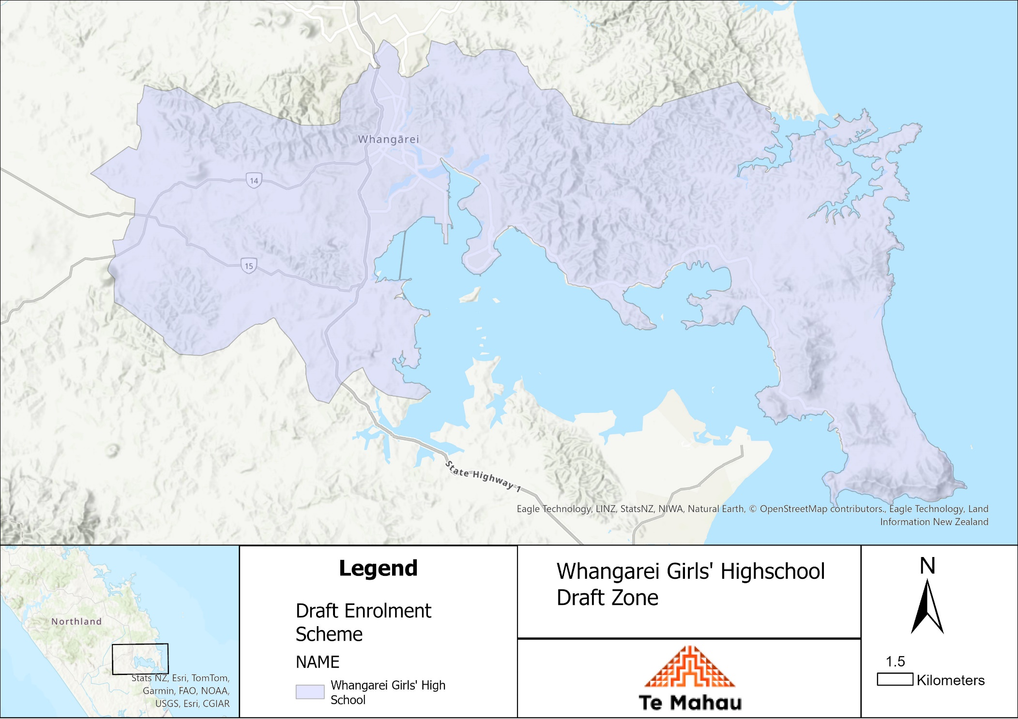

What does this mean for my family?
Any student currently enrolled at Whangārei Girls’ High School will not be impacted by the new enrolment scheme. All students enrolled (and attending school) will be entitled to continue attending Whangārei Girls’ High School, irrespective of where they currently live.
The establishment of the enrolment scheme and home zone will affect all enrolments starting at the beginning of Term 1 2025. This includes current families who have a younger sibling looking to enrol at Whangārei Girls’ High School starting on 1 January 2025 (the commencement date) or later. The flowchart below will help you assess your indicative eligibility to enrol after the commencement date.
Does your child (enrolling in 2025 or later) live within the enrolment scheme home zone? (check map for reference)
In zone enrolment
YES

NO
Out of zone enrolment
(if places available)

YES
Does your child (enrolling in 2025 or later) live outside of the zone?

Whangārei Girls’ High School is expecting to ballot a significant number of the total school roll in 2025. Hostel students are in zone.

Consultation process and timeline
The Ministry of Education is currently undertaking consultation about the proposed changes and new enrolment schemes. You can have your say by:
Completing the survey at: https://consultation.education.govt.nz/whangarei-girls-highschool Consultation page.

- This site also has further information about the proposed scheme.
- Emailing taitokerau.enrolmentschemes@education.govt.nz if you have further questions or comments.
Consultation will run 1 April 2024 to 13 May 2024. The Ministry will consider all feedback and liaise with the Whangārei Girls’ High School Board before making a final decision. We expect the school community to be updated about progress made 10 June 2024. The new scheme and changes will come into effect for enrolments after the commencement date 1 January 2025

