Whau Valley School

New Enrolment Scheme

Overview – what is changing?
The Ministry of Education regularly monitors enrolment patterns, population growth and anticipated school roll changes across the Whangarei district. As part of this monitoring and regular review, we now consider an enrolment scheme is necessary for Whau Valley School. This is due to growth of the school roll and because we need to ensure the Board has a fair and transparent mechanism to manage the roll. It also means we can ensure we are making best use of educational facilities across the wider Whangarei area.
The new enrolment scheme will have a home zone, like other schools with enrolment schemes in the area. Children that live within this area will have entitlement to enrol at Whau Valley School. The home zone area is shown on the map below and described here:
WHAU VALLEY SCHOOL (#1131)
Proposed Draft Enrolment Scheme
Commencement date: 22 July 2024

The guidelines for development and operation of enrolment schemes are issued under Schedule 20, Clause 3 (3) of the Education and Training Act 2020 for the purpose of describing the basis on which the Secretary’s powers in relation to enrolment schemes will be exercised.
Home Zone

All students who live within the home zone described below (and shown on the attached map) shall be eligible to enrol at the school.

From the intersection of McClintock St and Kamo Road outside Whau Valley School the zone travels north along McClintock St and then turns right into Weaver St. All McClintock St addresses are included. The zone travels along Weaver St and then turns left onto Moody Ave (to include all Moody Ave addresses). The zone then turns left from Moody Ave onto Kamo Rd and turns left into Keyte St, travelling through Curtis St as far as number 57 Keyte St. From here the zone travels east along McLean St to include the south side of McLean St and onto to King St to include the south side of King St. From the King St/Cairnfield Road intersection the zone turns right and travels south along Cairnfield Road to include the west side of Cairnfield Road as far as the Waiatawa road and Mill Road intersection. From here the zone turns right onto Mill Road and travels south up to but not including Hassard St. Note that only addresses on the west side of Mill Road are in-zone. From there the zone turns around and heads back north to Churchill St. The zone turns left onto Churchill St and travels west to the Mains Avenue intersection. From here the zone turns left into Mains Ave and travels south to include all Mains Ave addresses up to Kamo Road. Turn left onto Kamo Road and travel south to the Nixon St intersection. The zone then turns around and travels back up Kamo Rd to the Percy St intersection. All addresses on Simons St, Islington St, Park Ave, Park Lane, Corns St, and Killen St are included.

The zone then travels west along Percy St to Western Hills Drive. Turn left into Western Hills Drive and travel south as far as number 134 Western Hills Drive. Note that Western Hills Drive addresses from number 136 Western Hills Drive up to the Kensington Drive intersection are not included as in-zone. From the Western Hills Drive and William St intersection, the zone travels west along William St and onto Arthur St and then turns left onto Douglas St and then onto Russell Road travelling as far as the Russell Road Scenic Reserve. Addresses accessing this section of Russell Road are in-zone i.e. Walnut Grove, Monowai Pl, Lilicoe Lane, and Kensington Heights Rise.

From the end of Kensington Heights Rise, the zone travels west across country to the end of Whau Valley Road by the Whau Valley reservoir. The zone travels east along Whau Valley Road to Kamo Road to include all addresses accessing Whau Valley Road i.e. Bullock Ridge, Halcyon Place, and Huia St. The zone turns left onto Kamo Road and travels north up to and including number 345A Kamo Road. From here the zone turns back along Kamo Road and travels south to the McClintock Road intersection.

All residential addresses on included sides of boundary roads and all no exit roads off included sides of boundary roads are included in the zone unless otherwise stated.

Section 75 of the Education and Training Act 2020 states that

“the Secretary may authorise an enrolment scheme to permit a student to enrol at the school as if the student lived in the home zone of the school if, -

(b) in the case of a new enrolment scheme, the student,

1. lives outside of the home zone of the new enrolment scheme; and
2. has a sibling who is enrolled at the school at the time that the new enrolment scheme is implemented.”

Special Programmes
This priority category is not applicable at this school because the school does not run a Special programme approved by the Secretary.
Out of Zone Enrolments
Each year the Board of Trustees will determine the number of places which are likely to be available in the following year for the enrolment of students who live outside the home zone. The Board will publish this information by public notice in a medium appropriate to the area served by the school. The notice will indicate how applications are to be made and will specify a date by which all applications must be received.
Applications for enrolments will be processed in the following order of priority:
First Priority
This priority is not applicable at this school because the school does not run a special programme approved by the Secretary for Education.
Second Priority
will be given to applicants who are siblings of current students.
Third Priority
will be given to applicants who are siblings of former students.
Fourth Priority
will be given to any applicant who is a child of a former student of the school.
Fifth Priority
will be given to any applicant who is either a child of an employee of the board of the school or a child of a member of the board of the school.
Sixth Priority
will be given to all other applicants.

If there are more applicants in the second, third, fourth, fifth or sixth priority groups than there are places available, selection within the priority group will be by ballot conducted in accordance with instructions by the Secretary, under Schedule 20, Clause 3 (1) of the Education and Training Act 2020. Parents will be informed of the date of any ballot by public notice in a medium appropriate to the area served by the school.
Applicants seeking second or third priority status may be required to give proof of a sibling relationship.

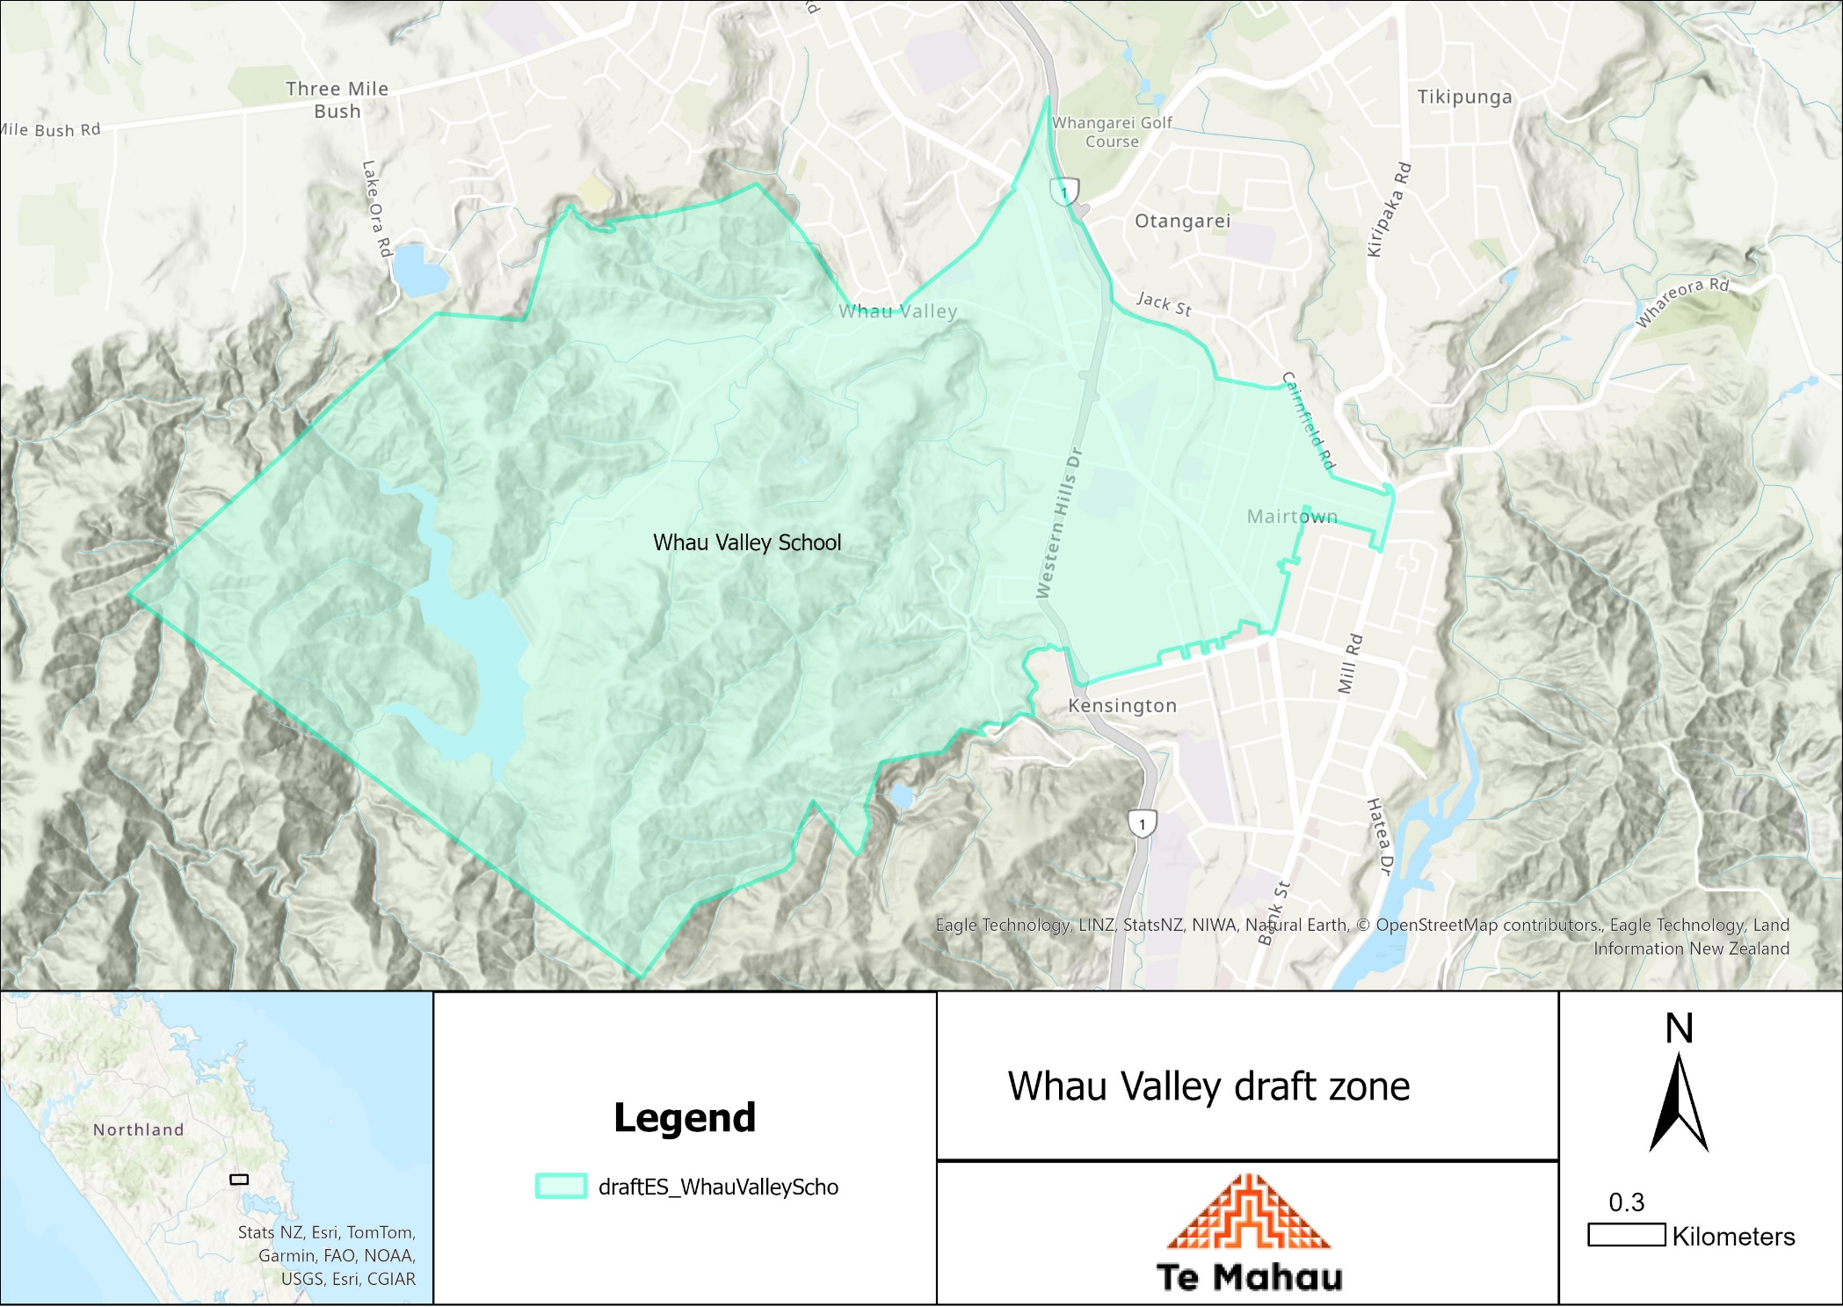

What does this mean for my family?
Any student currently enrolled at Whau Valley School will not be impacted by the new enrolment scheme. All students enrolled (and attending school) will be entitled to continue attending Whau Valley School, irrespective of where they currently live.
The establishment of the enrolment scheme and home zone will affect all enrolments starting at the beginning of Term 3 2024. This includes current families who have a younger sibling looking to enrol at Whau Valley School starting on 22 July 2024 (the commencement date) or later. The flowchart below will help you assess your indicative eligibility to enrol after the commencement date.
Does your child (enrolling in 2024 or later) live within the enrolment scheme home zone? (check map for reference)
In zone enrolment
YES

NO
Out of zone enrolment
(if places available)

YES
Does your child (enrolling in 2024 or later) live outside of the zone?

Consultation process and timeline
The Ministry of Education is currently undertaking consultation about the proposed changes and new enrolment schemes. You can have your say by:
Completing the survey at: https://consultation.education.govt.nz/ on the Whau Valley School Consultation page.

- This site also has further information about the proposed scheme.
- Emailing taitokerau.enrolmentschemes@education.govt.nz if you have further questions or comments.
Consultation will run 14 May 2024 to 22 June 2024. The Ministry will consider all feedback and liaise with the Whau Valley School Board before making a final decision. We expect the school community to be updated about progress made 4th July 2024. The new scheme and changes will come into effect for enrolments after the commencement date 22 July 2024.

