Wymondley Road School

New Enrolment Scheme

Overview – what is happening?
The Ministry of Education is developing an enrolment scheme for Wymondley Road School, which will be in effect for the beginning of term 2 in 2022. Having an enrolment scheme in place will ensure the Board of Trustees has a fair and transparent mechanism to manage the roll as it grows. Children that live within this area will have entitlement to enrol at Wymondley Road School. The home zone area is shown on the map below and includes:
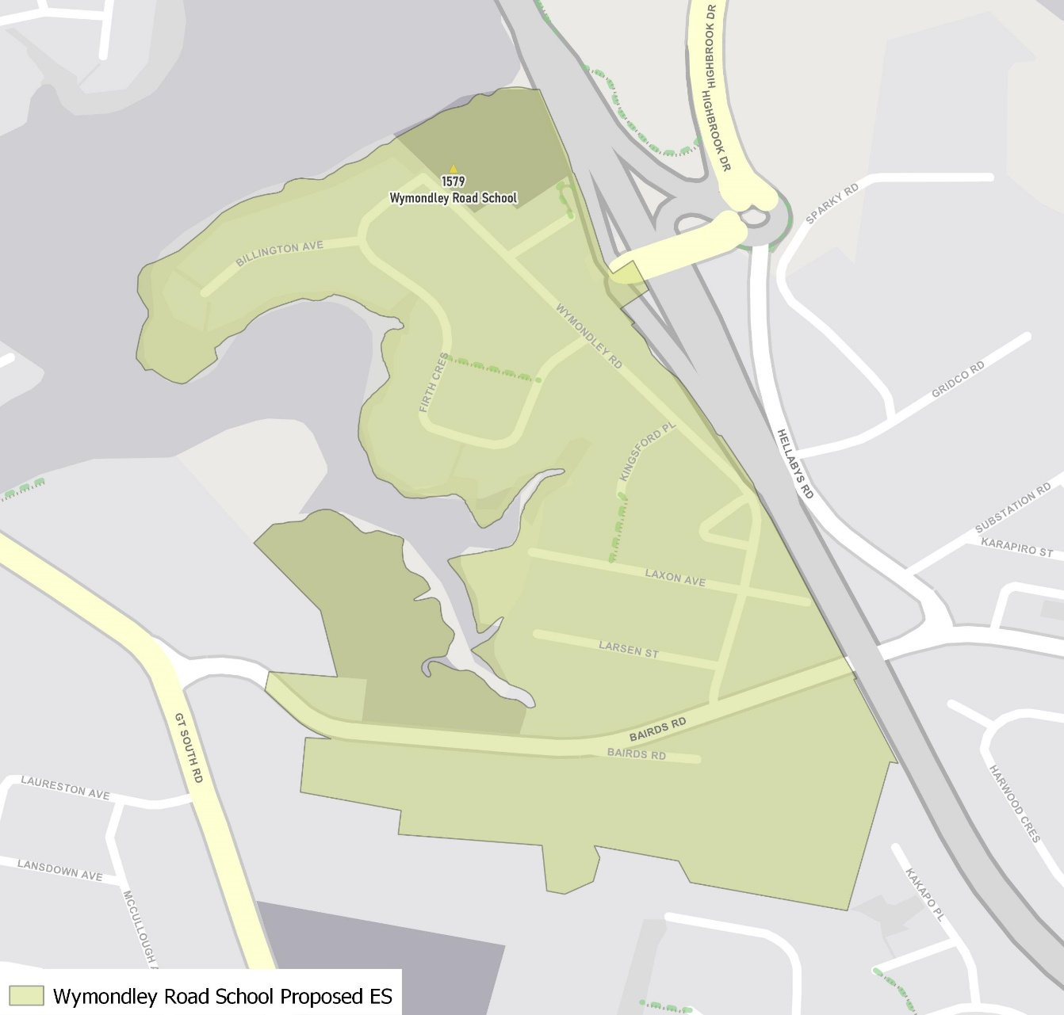
Starting at 1 Bairds Road (south side of road) / 28 Bairds Road (north side of road), travel east along Bairds Road until State Highway 1, including both sides of the road. Travel north along SH1 until Tamaki River, at which point travel initially west along the coastline until the boundary’s origin point. Within the boundary, all of Larsen Street, Wymondley Road, Laxon Ave, Clarrie Wills Way, Kingsford Place, Firth Crescent, Sterling Street and Billington Avenue are included.

What does this mean for my family?
If you live in enrolment scheme home area for Wymondley Road School, you will be entitled to enrol your child at the school. This entitlement applies to new students starting school, as well as any students currently attending another school in the area.
Families who live outside the enrolment scheme home zone of Wymondley Road School do not have entitlement to enrol and could only attend if the Board of Trustees planned to enrol any out of zone students. The enrolment scheme will establish the process for this, and places will only be available if the Board of Trustees considers it has the capacity to allow for this. Further information about whether any out of zone places will be made available will be made later in 2021.

Consultation process and timeline
The Ministry of Education is currently undertaking consultation about the new enrolment scheme. You can have your say by:
- Completing the survey at https://consultation.education.govt.nz/education/wymondley-road-school-enrolment-scheme
- Emailing auckland.enrolmentschemes@education.govt.nz if you have further questions or comments
The Ministry will consider all feedback and liaise with the Board before making a final decision. The new schemes and changes will come into effect for the beginning of Term 2 2022.

