# Evidence Brief

# Consultation to develop a Long-Term Insights Briefing: Youth at risk of limited employment

## About this Document

1. The Ministry of Social Development, Ministry of Business, Innovation and Employment and Ministry of Education are developing a Long-Term Insights Briefing on youth at risk of limited employment.
2. Long-Term Insights Briefings are public documents with information, analysis, and a range of policy options on important topics, trends, risks and opportunities that affect New Zealand.
3. The final Briefing will be available to the public and will be a resource with information, analysis and policy options to help government and communities support youth at risk of limited employment more effectively.
4. This document provides further detail on what we currently know about the experiences of young people, covering broad trends in the labour market, and the social welfare and education systems.
5. Youth at risk of limited employment are a group of 16 to 24-year olds who cycle between low-paid short-term jobs, unemployment and/or lower-level tertiary education.
6. They lack access and opportunity through barriers they have no control over, rather than lack of ability or potential.
7. Research shows young people who get stuck in this cycle at the start of their working lives are much more likely to continue this pattern into adulthood. If not effectively supported, they are more likely to remain in low wage jobs, or be under-employed, or unemployed for much of their lives. Employment outcomes have strong links to social wellbeing.

## A note on data

1. The Government response to the issues facing young people over the last decade has largely focused on reducing numbers of young people who are not in employment, education or training (NEET). NEET is a well-established and internationally recognised category; therefore, much of the information presented in this document is focussed on NEETs. There is limited New Zealand analysis done on the cohort of 16 to 24-year olds who are at risk of limited employment – therefore we have had to use NEET as a proxy.
2. We also know that income levels and poverty have a bearing on limited employment for young people; however, data on these measures in relation to young people and their employment outcomes is limited.

## General labour market trends and performance

1. New Zealanders’ wellbeing depends on the labour market functioning well. A well-functioning labour market has:
   1. enough work for those who are able and want to work
   2. good work/life balances
   3. firms able to efficiently access the quantity and type of workers they need, when and where needed
   4. equity of labour market opportunities across the labour force, and across the life cycle
   5. laws that protect workers from exploitation, and checks and balances on abuses of power by employers
   6. effective use of domestic human capital and people’s potential in paid employment and other activities (such as caregiving)
   7. effective and efficient matching and smooth transitions between jobs and into and out of the labour force
   8. sharing of costs, risks and rewards of labour market participation
   9. resilient and adaptable institutions, business and workers
   10. increasing social connections, including opportunities to contribute.
2. New Zealand’s past labour market performance is mixed, with overall strengths in creating a high number of jobs, high participation rates in the labour force and delivering some elements of job quality, such as flexibility and autonomy (see **Annex One**). However, a number of long-term problems endure:
   1. Low labour productivity and low real wages
   2. Significant prevalence of low-quality jobs
   3. Ongoing skills supply and matching problems at individual and aggregate levels
   4. While New Zealanders are well-educated in aggregate, employers often say they can’t find the right workers, and workers often say they struggle to find the right jobs
   5. Persistently poor outcomes for particular populations and regions, with pockets of serious distress.
3. There remain significant gaps in employment outcomes between certain population groups and the total population, including for young people, Māori, Pacific people, women, and disabled people, as well as those who do poorly in education and experience poverty.

## Past trends and current state for young people

### Demographic information

1. The 2018 Census recorded 619,000 people aged between 15 and 24 years old across the country, comprising 13.2% of the total population.
2. Among the total population, around 70% identify as European, 16.5% as Māori, 15% as Asian, 8% as Pacific, and 1.5% as Middle Eastern/Latin American/African. The 15 – 24 year old population has a lower proportion of those identifying as European and higher proportions identifying with other groups. Two thirds are European, 22% are Māori, 17% Asian, 12% Pacific, and 1.6% Middle Eastern/Latin American/African.

|  |  |  |  |
| --- | --- | --- | --- |
| Highest proportion of 15 – 24 year olds compared to the total area population | % | Highest number of 15 – 24 year olds by territorial authority area | Number |
| Dunedin City | 20.22% | **Auckland** | 223,689 |
| Wellington City | 17.38% | **Christchurch City** | 52,146 |
| Palmerston North City | 16.91% | **Wellington City** | 35,226 |
| Hamilton City | 16.26% | **Hamilton City** | 26,169 |
| Auckland | 14.23% | **Dunedin City** | 25,533 |
| Christchurch City | 14.13% | **Tauranga City** | 14,658 |
| Porirua City | 13.02% | **Palmerston North City** | 14,316 |
| Rotorua District | 12.68% | **Lower Hutt City** | 13,038 |
| Lower Hutt City | 12.47% | **Hastings District** | 9,876 |
| Gisborne District | 12.29% | **Whangarei District** | 9,846 |
| Total - Territorial Authority areas | 13.18% | **Total - Territorial Authority areas** | 619,218 |

Source: StatsNZ Census 2018

1. The table above shows territorial authority areas where young people are most highly concentrated by their total numbers, or as a proportion of the 15 – 24 year old population. The table below shows this by ethnicity. Auckland has the highest total numbers of 15 – 24 year olds identifying as Māori, Pacific peoples, and Asian. The areas with the highest proportions of Māori in their 15 – 24 year old populations are Ōpōtiki, Hastings and Gisborne. Upper Hutt, Thames-Coromandel and Waitomo have the highest proportions of Pacific Peoples in their youth populations, while the areas with the highest proportions of Asian young people are the Thames-Coromandel, Waipa and Far North districts.

|  |  |  |  |  |  |
| --- | --- | --- | --- | --- | --- |
| Māori - Highest number | Māori - Highest proportion | Pacific Peoples - Highest number | Pacific Peoples - Highest proportion | Asian - Highest number | Asian - Highest proportion |
| Auckland (33231) | Opotiki District (80.41%) | Auckland (47,346) | Upper Hutt City (36.91%) | Auckland (66219) | Thames-Coromandel District (29.6%) |
| Hamilton City (7506) | Hastings District (80.17%) | Christchurch City (2,736) | Thames-Coromandel District (21.16%) | Christchurch City (8,565) | Waipa District (17.27%) |
| Christchurch City (7002) | Gisborne District (78.61%) | Porirua City (2,718) | Waitomo District (17.43%) | Wellington City (5,904) | Far North District (17.16%) |
| Rotorua District (4755) | Waitaki District (72%) | Lower Hutt City (2,223) | Wellington City (17.05%) | Hamilton City (4,521) | Masterton District (16.76%) |
| Far North District (4509) | Wairoa District (66.18%) | Wellington City (2,163) | Napier City (11.96%) | Dunedin City (3,225) | Selwyn District (16.42%) |
| Whangarei District (4332) | Whangarei District (64.89%) | Hamilton City (2,103) | Far North District (11.79%) | Lower Hutt City (1,926) | Wellington City (14.77%) |
| Wellington City (4137) | Kawerau District (63.74%) | Hastings District (1,182) | Kapiti Coast District (9.7%) | Palmerston North City (1,893) | Tararua District (13.22%) |
| Tauranga City (4053) | Whanganui District (60.35%) | Dunedin City (1,173) | Lower Hutt City (8.46%) | Tauranga City (1,470) | Clutha District (12.63%) |
| Gisborne District (3864) | Taupo District (59.73%) | Palmerston North City (912) | Manawatu District (8.42%) | Rotorua District (915) | Dunedin City (12.39%) |
| Hastings District (3699) | Whakatane District (52.17%) | Tauranga City (708) | Waipa District (8.03%) | Hastings District (678) | Tauranga City (10.74%) |

Source: StatsNZ Census 2018

### Educational achievement and outcomes for young people

1. Education can equip young people with the skills and competencies they need for life, and for participating in the labour market. While New Zealand’s school system performs very well for many students, it does not perform well for everyone. A significant proportion of Māori and Pacific young people from low socio-economic backgrounds, and students with additional learning needs, are not seeing the benefits of education at all levels.
2. Research shows that attending (and staying in) school and attaining qualifications are protective factors to young people not becoming at risk of limited employment. The headline measures for these factors have both been declining in recent years for the total population and are worse for some groups. Additionally, modelling shows that lower educational attainment levels are one of the risk factors contributing to a higher likelihood for people to stay on benefit for longer periods of time. The graphs below show that NCEA level 2 attainment rates, and literacy and numeracy achievement have plateaued, and have shown slight declines in recent years. Disparities by gender and ethnicity are persistent. Further, the results from the OECD Programme for International Student Assessment (PISA) indicate that the maths and reading levels of New Zealand students have been decreasing over a number of years.[1]

**Percentage of 18-year olds with at least an NCEA Level 2 qualification or equivalent, by ethnic group and gender (2009 to 2019)**

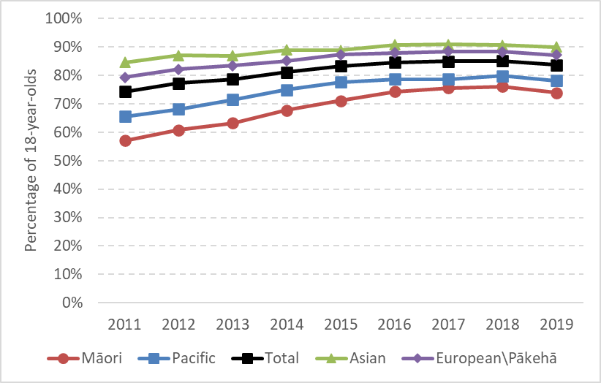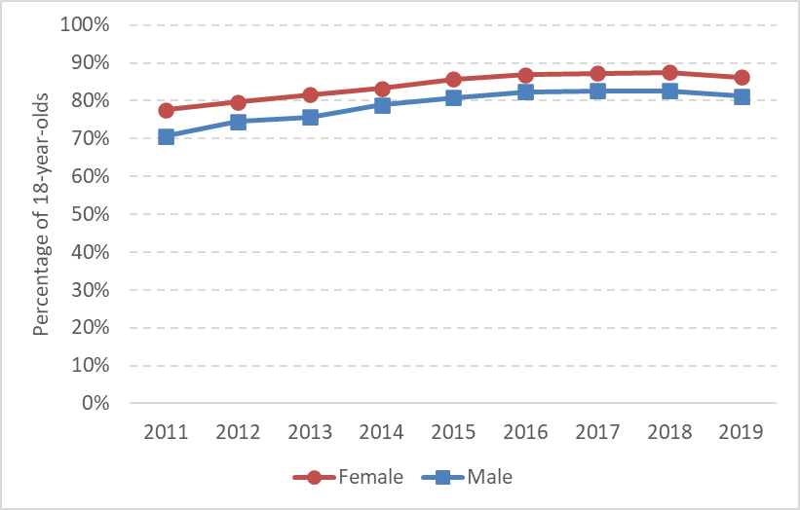

Source: Ministry of Education

**Percentage of Māori school leavers with NCEA Level 2 or higher, for Māori-medium and English-medium schools**

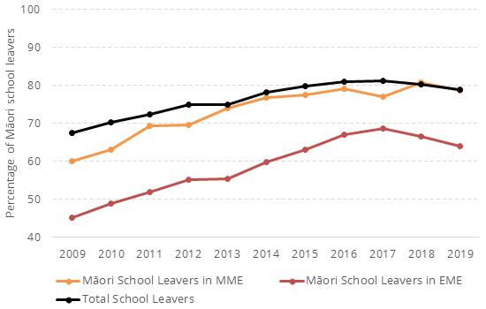

Source: Ministry of Education

**Percentage of total school leavers with NCEA Level 1 literacy and numeracy (2009 to 2019)**

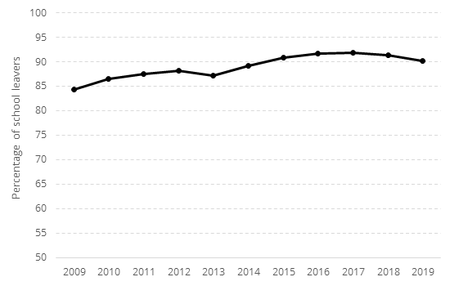

Source: Ministry of Education

**PISA shows that mathematics and readings scores for NZ 15-year olds have been declining since 2000**

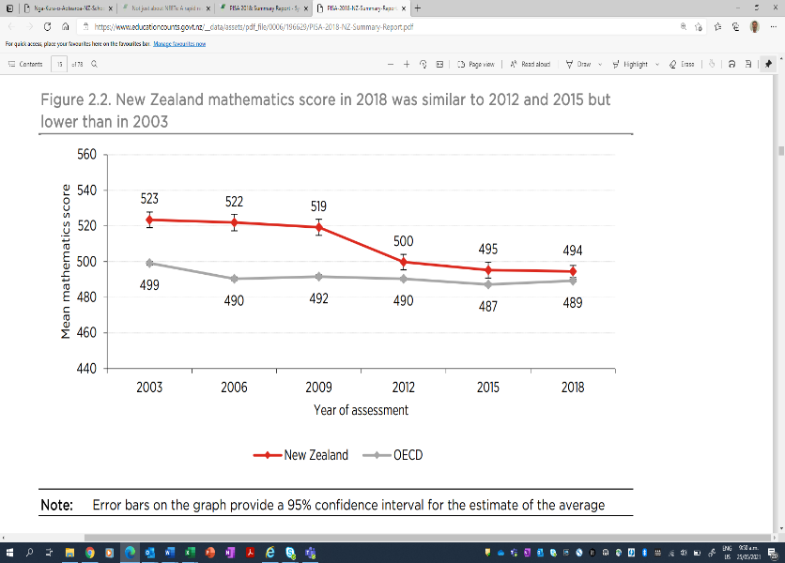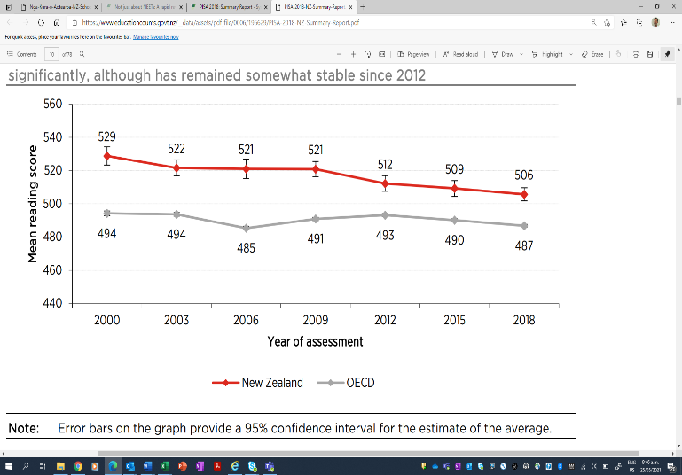

Source: PISA

1. Another risk factor is poor engagement and attendance while still enrolled at school. Regular school attendance is unacceptably low and has been falling since 2015. In 2019, 58% of students attended school ‘regularly’ (at least 90% of school days). 2020 saw a rebound following the national lockdown; however, there is no basis to expect this reversal of the trend to continue.

**The percentage of students attending school regularly**

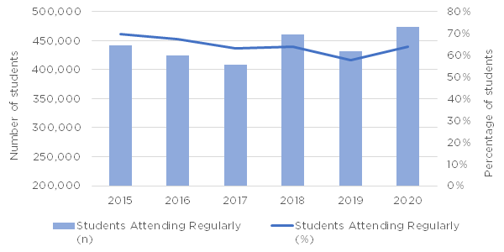

Source: EdCounts: <https://www.educationcounts.govt.nz/statistics/attendance>

1. One risk factor for becoming at risk of limited employment is leaving school with no qualifications, and regular attendance is a proxy for wellbeing and engagement. PISA data shows that, like attendance, other measures of wellbeing and engagement are also trending down. The PISA also shows that the more negative measures (feeling like an outsider, or awkward) are trending up, and the risk factors for this include being in poverty and interacting with the youth justice system. This is likely to result in more young people being less engaged at school, and therefore at greater risk of leaving school with no or low qualifications and at greater risk of limited employment.

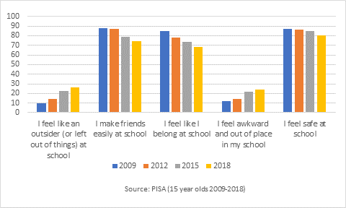

1. Students who leave school at 16 are three times more likely to be NEET. These students are also more likely to have been stood down, been highly transient and/or truant and received learning support. While school stand-down rates have increased since 2015, the rate of transience[2] has decreased since 2016.

**Age-standardised school stand-down rates (2000 to 2019)**

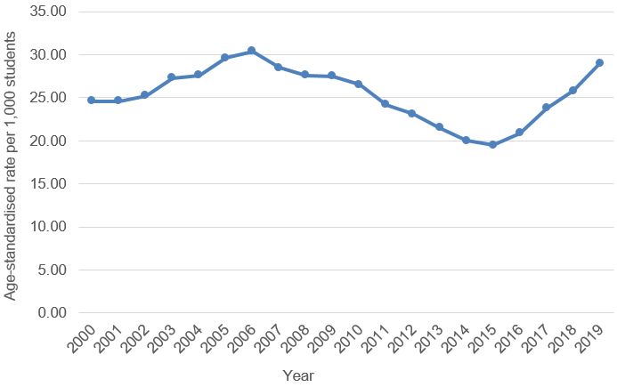

Source: EdCounts <https://www.educationcounts.govt.nz/indicators/main/student-engagement-participation/Stand-downs-suspensions-exclusions-expulsions>

**Transient students per 1,000 enrolled students (2011 - 2019)**

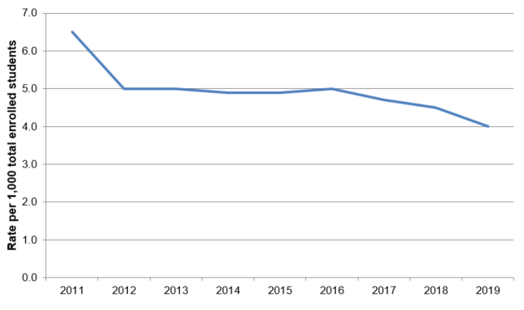

Source: EdCounts: <https://www.educationcounts.govt.nz/indicators/main/student-engagement-participation/transient-students>

## Young people in the labour market

1. Young people have lower rates of employment than other age groups; however, this is not always a cause for concern due to the high levels of participation in education among this age group. However, a notable segment of the youth population face challenges to attaining skills and transitioning to the labour market or further education. The graph below sets out the labour force and education status of 15 – 24 year olds, showing the vast majority are in employment and/or education. Around 90,000 young people are either unemployed and not in education, not in the labour force due to caregiving responsibilities or are not in the labour force or education and not caregiving. Young women also have higher NEET rates, partially due to caring responsibilities.
2. We know that in recessions, as employers need to make hard decisions about their business and workforce, the impact is often most felt by new entrants to the labour market. Employers are less likely to take a chance on a young person entering the workforce for the first time. Data from past recessions showed the unemployment rate for 15- to 24-year-olds rose from about 9 to 15% compared with an increase from 3.5 to 6.5% for the general population.

Source: Household Labour Force Survey

Source: Household Labour Force Survey

**New Zealand youth activity by year of age, 2019**

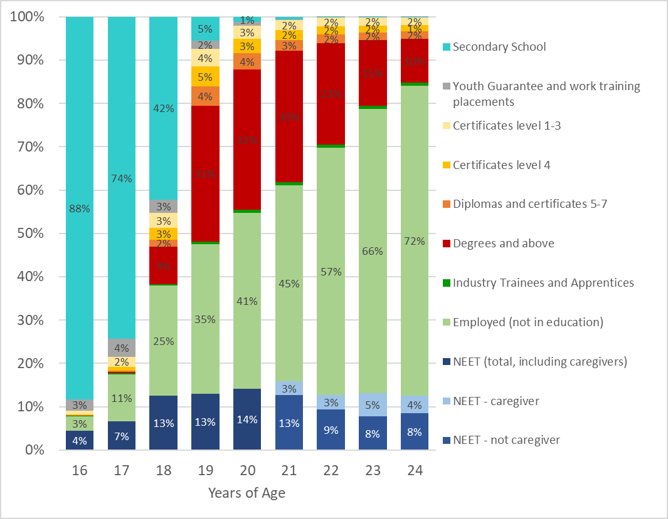

Source: Education Counts [www.educationcounts.govt.nz/statistics/post-compulsory-education-and-training](http://www.educationcounts.govt.nz/statistics/post-compulsory-education-and-training)

**New Zealand youth activity by age group and selected ethnicity, 2019**

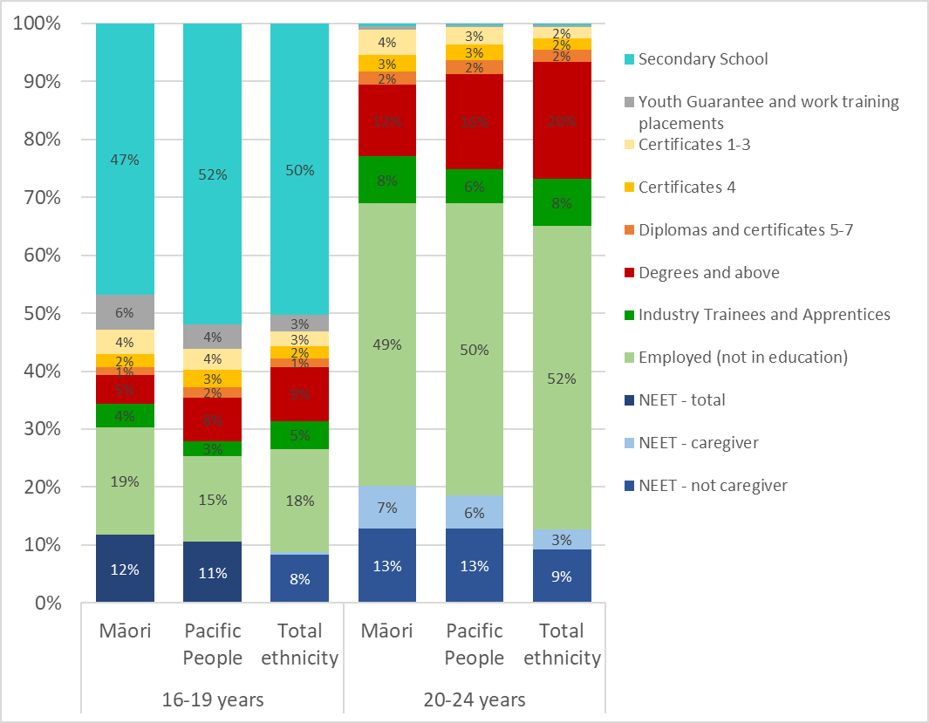

Source: Education Counts [www.educationcounts.govt.nz/statistics/post-compulsory-education-and-training](http://www.educationcounts.govt.nz/statistics/post-compulsory-education-and-training)

1. Labour market disadvantage is particularly marked for youth with disabilities and chronic health conditions. Disabled youth are much less likely to be employed or to be participating in education or training. The NEET rate for young disabled people aged 15–24 years was at 48.2% as at June 2020, compared with 10.6% for non-disabled youth.

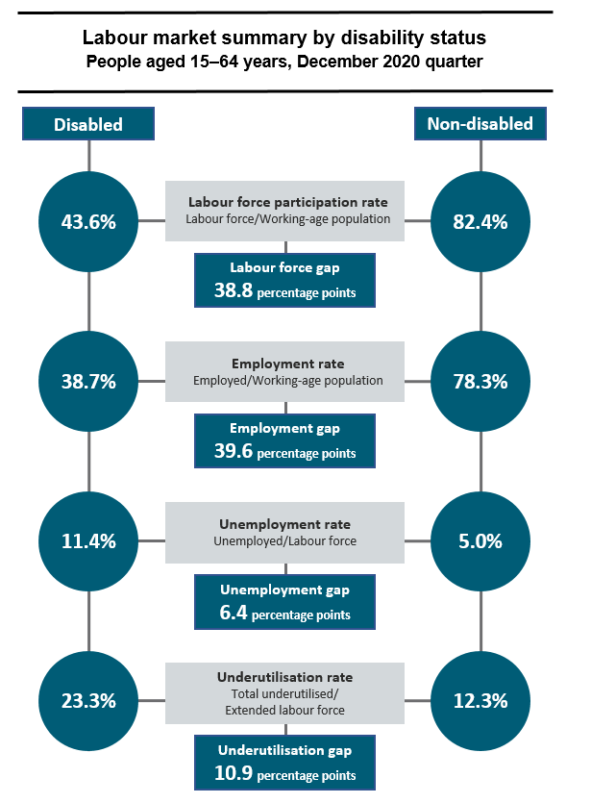

Source: Household Labour Force Survey

Source: Household Labour Force Survey

## The impact of COVID-19 on the labour market and young people

1. COVID-19 has had a significant impact on the labour market. New Zealand’s response to date has been to close the border to non-residents, greatly reducing the movement of people across the border. Industries most reliant on people movements were the most affected (food services/hospitality by lockdowns and tourism by border closures).
2. The rebound in labour demand has been faster than initially anticipated. Unemployment went up in the September 2020 quarter but has dropped since then, although it remains higher than pre-COVID. Employers who originally intended to reduce labour demand once the wage subsidy ended have become more optimistic about hiring.
3. Young people continue to be disproportionately negatively affected by the recession and may be adapting to the challenges of COVID-19 by increasing their time in education and training (similar to what we have seen in past recessions).
4. Although the unemployment rates seem to have held up for those aged 15 to 24, both the employment and participation have decreased in March 2021 compared to last year (HLFS).
5. Lower participation in the labour market may reflect higher enrolments into study.
6. We have seen more young people exiting main benefit into study over the last few months than usual. Exits from benefit into study were up by 71% for those aged 18 to 24 years in March 2021 compared to last year, which is similar to the trend during the Global Financial Crisis (GFC).
7. The number of people who were NEET appears to have slightly increased in the March 2021 quarter, which is typical for this time of year.
8. Over the year, young people in education is up (by 20,000 to 329,000 people), while those who are not in education is down (by 27,000 to 320,000 people).

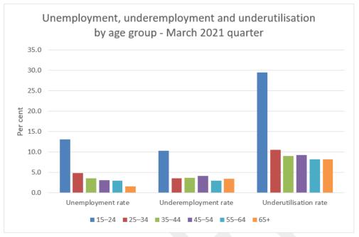

Source: Household Labour Force Survey

1. The immediate future effects of COVID-19 on the labour market are very uncertain, and depend on a complex mix of factors and impacts are still emerging.
2. Young people have seen employment loss from the economic effects of COVID-19, however participation in education has increased (which is normal in weaker economic conditions). The national seasonally adjusted NEET rate has increased to 13.1% nationally, however there is significant volatility in this measure – the NEET rate in March 2019 was also at this level. There is some variation in the NEET rate across regions, but most of the differences are not statistically significant.

## Young people’s interactions with the social welfare system

1. Around 16% of the 18–24-year-old population was receiving a main benefit at the end of December 2020, which is higher than for the rest of the working-age population (12%). 18–24-year olds make up 18% of all main benefit recipients. Through 2020, their number increased, driven by the economic disruption caused by COVID-19. However, this younger cohort has since decreased from 74,000 in December 2020, to 59,000 in May 2021.
2. The majority (71%) of youth on a main benefit receive Jobseeker Support (JS). Representation of youth on this benefit has followed a similar pattern to overall main benefit receipt, due to Jobseeker Support representing the largest proportion of overall main benefit take-up.
3. Most of the growth in those receiving Jobseeker Support comes from 20–-24- year olds. This group was the quickest to enter benefit due to the effects of COVID-19 but has also been the group to leave benefit fastest.

Source: Ministry of Social Development

1. Unlike other benefits (like JS), the number of people receiving Supported Living Payment (SLP) changes slowly over time, as people must have a long-term health condition or disability to be eligible for SLP.
2. Receipt of Sole Parent Support (SPS) has been decreasing over the last five years. This is partly driven by the operational changes made in October 2016 when the youth services program was extended to 18-19 year olds, and young parents were no longer eligible for SPS. There has been, however, a small increase in uptake among this cohort since COVID-19.
3. Receipt of the Youth Payment (16 – 17 years) and Young Parent Payment (16 – 19 years) during 2020 peaked in September. However, receipt was still lower than that seen in the second half of 2017. The number of recipients has been decreasing slowly over time.

Source: Ministry of Social Development

## Information on the effectiveness of interventions for young people

1. There are multiple risk factors for being a young person at risk of limited employment that fall within the labour market, social welfare, education, health (particularly mental health) and corrections domains. Interventions that do not take into account the broader factors influencing someone’s likelihood of success in the labour market can be limited in their effectiveness.
2. While we know there are some recent programmes or interventions that show signs of being effective, we also know that some programmes have been less effective and there is a need for more work to refine these.
3. The Productivity Commission’s 2015 report on its inquiry into more effective social services found that the system of social services had some positive attributes. This included a willingness of government agencies to launch trials and experiments, a committed workforce, pockets of innovation in certain areas and a general government commitment to improve social services. However, it also observed a range of weaknesses including not being suited to addressing multiple and inter-dependent problems, limited knowledge in government on what interventions work well, poor quality or absent evaluation (or use of evaluation information in subsequent decision-making), poor coordination between agencies and missing opportunities for early intervention.[3]
4. Previous research has suggested that interventions that include the following elements can be the most effective for youth at risk of limited employment:
   1. Programmes that focus on developing interpersonal and soft skills (such as time-management, working with others, resilience), that teach young people appropriate behaviour and norms in the workplace.
   2. Experience in the labour market, including opportunities for work experience. Work experience helps with signalling in the labour market – showing employers that a young person has the required skills and experience for employment, going beyond attainment of qualifications. There is a role for government and employers in facilitating opportunities for work experience.
   3. Programmes that combine multiple interventions and services – young people often face multiple barriers in the labour market, and programmes that only address one barrier are generally ineffective. While there is no specific combination of services that always works, programmes that provide wraparound supports (e.g.eg pastoral care, on-the-job training), regardless of what those are, tend to do better.
   4. Targeting and follow-up monitoring systems – research has found that programmes that provide targeted services based on level of need (eg from those requiring minimal support to the most disadvantaged or hard-to-reach) are better able to respond to those needs. Effective follow-up systems and incentives to keep young people in the programme are therefore also important for success.
5. Work is already underway across government to ensure services and support that have one or more of these features. Some of these are bespoke employment initiatives or services targeted at young people, while others are programmes of work aimed at improving the effectiveness of wider systems that affect labour market outcomes for young people:
   1. The Government has made a commitment to overhaul the welfare system to ensure it is fairer and more accessible for all New Zealanders. This includes work to improve and expand MSD’s employment services.
   2. MSD has a range of employment supports available to young people that can help provide training, upskilling, work experience and other wraparound supports (such as mentoring), to give them a better chance of achieving sustainable employment. MSD received $150 million through Budget 2020 to support the expanding and adjusting of MSD’s employment support services to enable MSD to take a more proactive and innovative approach with employers and employees. Some examples of employment services available through MSD include Mana in Mahi, the Youth Service[4], Flexi-Wage and Skills for Industry.
   3. Mana in Mahi supports people who are disadvantaged in the labour market and at risk of long-term benefit receipt to gain an apprenticeship or formal industry qualification, leading to long-term sustainable employment. Employers are supported with a wage subsidy, while participants can access pastoral care, incentive payments and other supports to help them to succeed. Mana in Mahi was given a boost of $30.3 million to support an expansion to the programme from August 2020.
   4. Foundation Education programmes (including through the Youth Guarantee Fees-Free programme) target people with no or limited qualifications. They aim to build core knowledge and skills so people can participate fully in their communities and in sustainable employment. Effective foundation education offers not only literacy and numeracy, but also many other ‘soft’ and transferable skills. Programmes can be offered in workplaces, tertiary education institutions and community settings. Learners often need effective pastoral care and support services alongside their education and training.
   5. The Reform of Vocational Education is reshaping the vocational education and training system. Previously separate on-job industry training and on-campus vocational education are being integrated as a single system. The reform is also aimed at increasing the quality of generic and transferable ‘soft skills’ in work-based training, and providing stronger links between off-site theory-based learning and work-based components.
   6. He Poutama Rangatahi (HPR) was started in 2017 as a pilot initiative and was subsequently expanded in later years, including receiving $34.5 million in ongoing annual funding in Budget 2020 to continue in the regions and expand into urban areas. HPR funds local projects designed to support rangatahi who are most at risk of long-term unemployment who may need extra individualised and ongoing support to connect to training and employment. Paid work experience and wraparound support such as pastoral care are a key element of HPR initiatives.
   7. The Māori Trades and Training Fund was allocated $50 million over two years as part of the COVID-19 Response and Recovery Fund (CRRF)[5] to support innovative community-designed initiatives that provide employment-focused training opportunities that are by Māori, for Māori. The MTTF has an emphasis on cohort and group-based approaches that are relevant and applicable to Māori. It is a similar model to HPR, but is not limited specifically to young people.
   8. Jobs and Skills Hubs work with employers involved in key construction and infrastructure projects to facilitate fast-paced jobs brokerage and training across a range of job levels and connect employers to the local workforce. Hubs also facilitate connections between employers and school leavers to help them learn about occupations and employment opportunities in their area.
   9. Māori and Pasifika Trades Training (MPTT) provides fees-free tertiary education places for Māori and Pasifika learners aged between 16 and 40. The programme combines trades training with mentoring and financial support, and connects trainees with employers in their chosen trade.

## Future trends

### Demographic

1. New Zealand’s population is aging, and we will also see shifts in the demographic composition of the population. In 2018, the median age was 37.2 years. By 2038, the median age is expected to be 42.2 years.[6] An ageing population may lead to shortages of qualified and skilled labour as retirement of older workers increases relative to the number of young people entering the labour market. The increasing proportion of Māori and of Pacific as a percentage of the population also means addressing equity in educational outcomes for Māori and Pacific learners is of urgent importance. Given the young age structure of the Māori and Pacific populations, there are significant benefits to be gained from improving outcomes for young Māori and Pacific peoples.

|  |  |
| --- | --- |
|  |  |

Source: StatsNZ

|  |  |
| --- | --- |
| Source: StatsNZ |  |

1. **Annex Two** shows population projections by ethnicity and region. We are expecting continued growth in urban areas and particularly the upper North Island). In future, young people will be increasingly concentrated in these areas.

### Industry trends

1. Different sectors and regions were in different positions prior to the COVID-19 recession and both their immediate and long-term needs will differ. Within the same sector or region, we may see both skill demand contraction and over-supply in some industries, as well as skills demand expansion and difficulty accessing skills and labour in others. This will have implications for the types of jobs available in future, their skills requirements and where they are located.

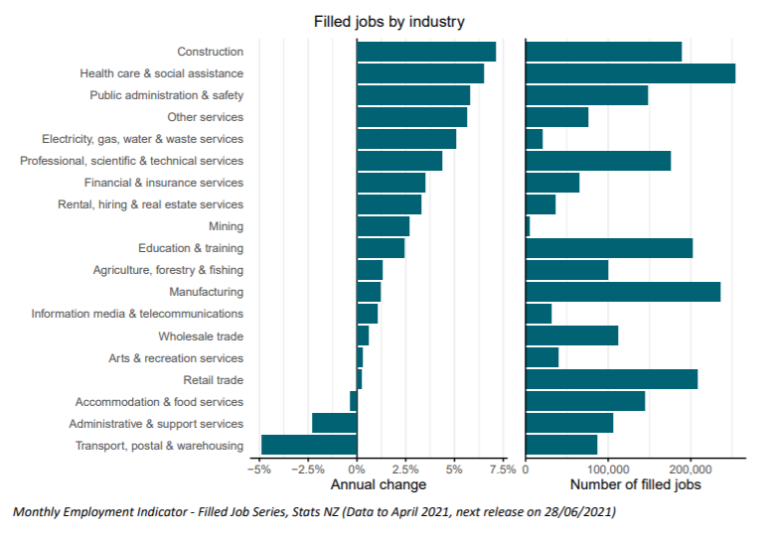

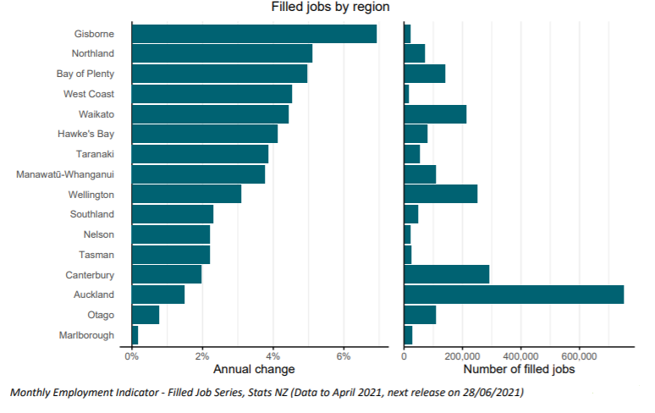

1. In the longer-term, industry composition is expected to change:
   1. Government intent is to drive volume to value-based industries, including raw primary sector/extraction to higher value chain such as agritech and food and beverage manufacturing
   2. Increased digital services and continuing demand for skills in this area
   3. An ongoing decline in manufacturing but also niche opportunities
   4. Medium term positive outlook for some sectors such as construction.
2. The figures below provide information on which industries currently have high proportions of young people. Young people are more likely to be employed in hospitality and retail compared to other age groups.

Graph shows the proportion at which 15 to 24 year olds are employed in various industries. Young people are more likely to be employed in hospitality and retail compared to other age groups.


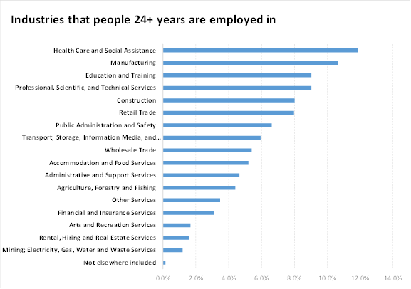

Source: StatsNZ Linked Employer-Employee Data

### Wider labour market trends

1. The nature of work continues to change. The impacts of this change have not been evenly spread and are likely to continue to impact most significantly on those already disadvantaged in the labour market. As with industry changes, these trends are likely to affect the labour market
2. Understanding trends affecting the future of work (FOW) has been the focus of research and policy work across both international and national agencies. In New Zealand, Government established a tripartite Future of Work forum to consider this. The Prime Minister’s Business Advisory Council also commissioned work on modelling the feasible impact of technology on New Zealand’s future economy and workforce.[7] This analysis suggested that FOW trends, which are already happening, could increasingly shift the nature of work and workplaces and the potential trajectory of occupations and industries, both globally and in New Zealand. These major trends are summarised below.
3. Technological change: Technology brings about the possibility of automating or replacing some types of labour, while opening up new types of work with new skill requirements. Internationally, increasing technological and workplace change has increased the vulnerability of jobs to automation and the displacement of workers. Evidence suggests, to date, this trend is less evident in New Zealand. Analysis by the Productivity Commission suggests low rates of technological adoption and spread throughout the economy have in fact contributed to New Zealand’s relatively poor labour productivity by international standards. Basic technology literacy will be ever more important as a foundation for sustainable employment, and to avoid exacerbating the “digital divide” and labour market disadvantage. Access to technology by households will become increasingly vital for skills development and labour market participation.
4. Globalisation: Greater flows of people, goods, finance and knowledge across national boundaries, and the institutions that support this. Diffusion of new technologies has allowed economies to become more tightly integrated. This encourages greater specialisation in what gets produced and how it is produced, with consequences for skill requirements and the type of jobs created. While global trade creates more jobs than it destroys, the costs and benefits of globalisation are not evenly distributed. COVID-19, however, has greatly disrupted the flow of people and goods globally and it is difficult to predict what longer term impacts this disruption will have on the economy and the local labour market.
5. Climate change and decarbonisation: Both climate change and Government’s target to reduce carbon emissions to zero by 2050 will cause some sectors to decline in importance and others to grow. This will also have greater impact on particular regions. The workforce profile of those sectors/regions with emissions-intensity varies considerably. While some are younger, low-paid with fewer qualifications; others are older, well-paid and may struggle to find equivalent jobs.
6. Demographic change: New Zealand’s population is both ageing (like many countries in the OECD) and becoming more ethnically diverse. An ageing population may lead to shortages of qualified and skilled labour as retirement of older workers increases relative to the number of young people entering the labour market. The increasing proportion of Māori and of Pacific as a percentage of the population also means addressing equity in educational outcomes for Māori and Pacific learners is of urgent importance. Given the young age structure of the Māori and Pacific populations, there are significant benefits to be gained from improving outcomes for young Māori and Pacific peoples.
7. Each of these factors are already having and will continue to have direct and indirect effects on the New Zealand economy and the labour market. It is unclear what the exact impact of these long-term global trends will have on New Zealand, or how these trends may have been impacted by COVID-19 and responses to it. However, as technology and the economy change it is likely emerging and new jobs will require higher levels of skills. Those in traditionally lower skilled jobs will be most vulnerable to job loss and displacement, which is likely to further exacerbate existing inequities in the labour market. In response to this, there is a need to focus on lifting skills for those in low-paid roles, so they are better prepared to adapt to a changing labour market.

## Annexes

* Annex One: Supporting labour market evidence
* Annex Two: Regional population projections

# Annex One: Supporting labour market evidence

New Zealand’s past labour market performance

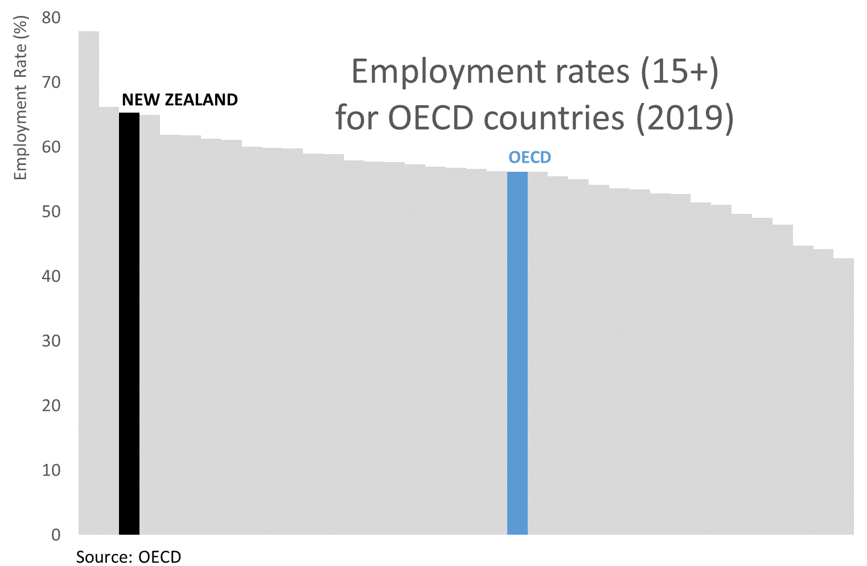

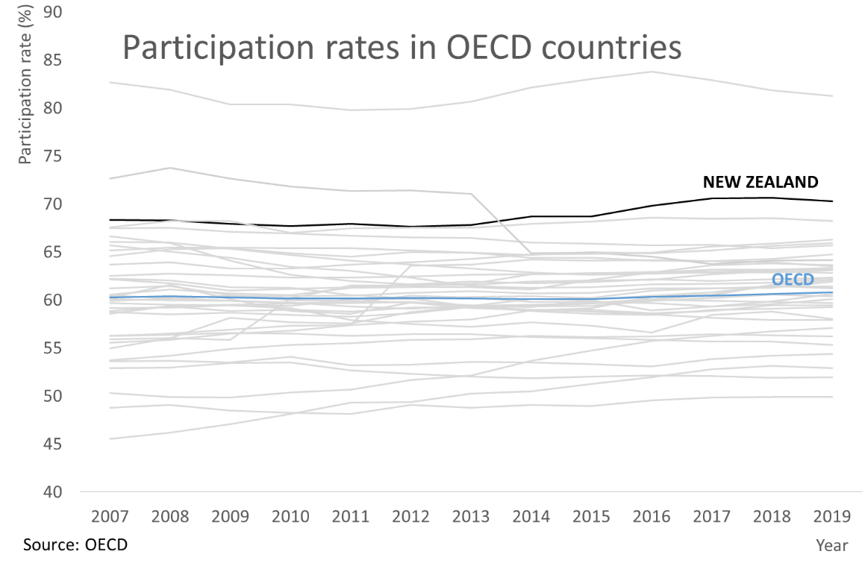

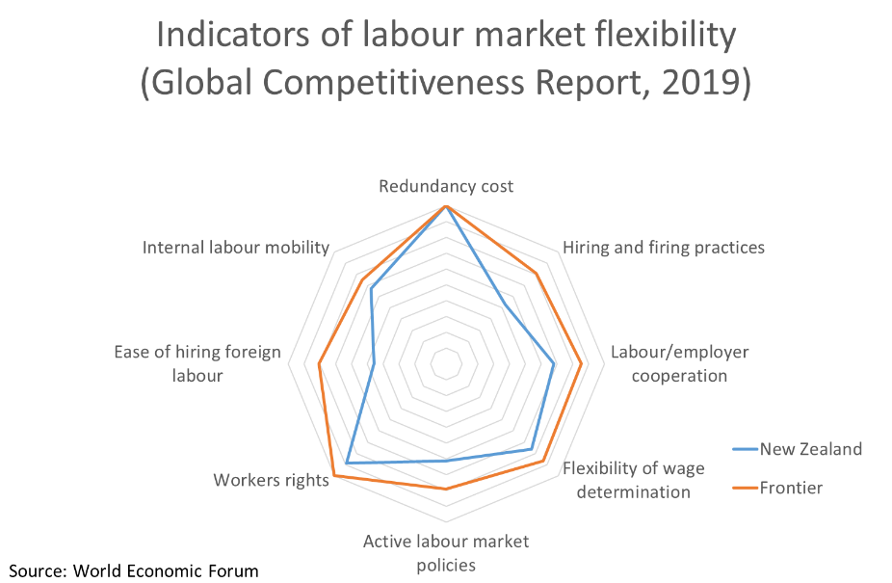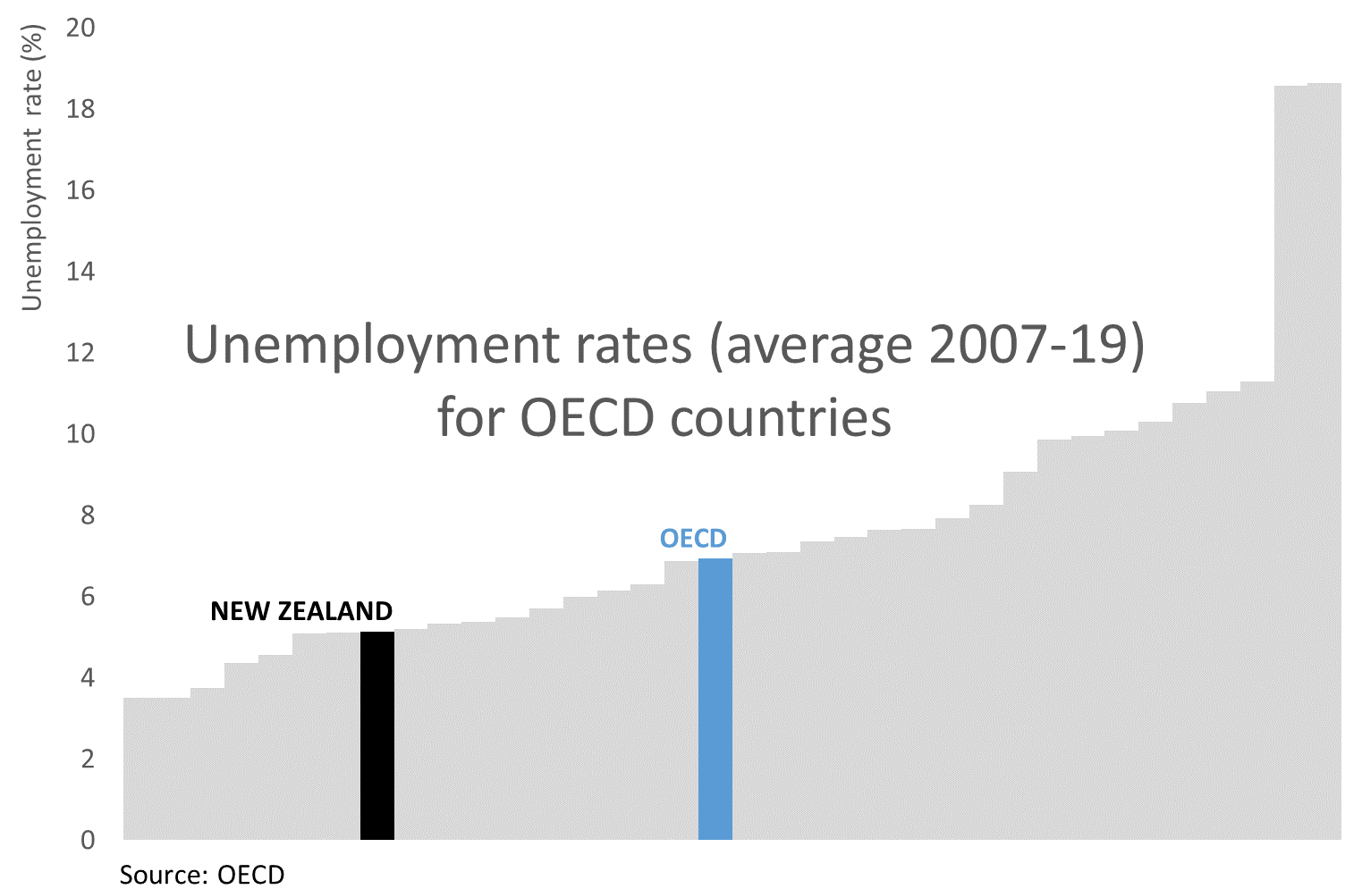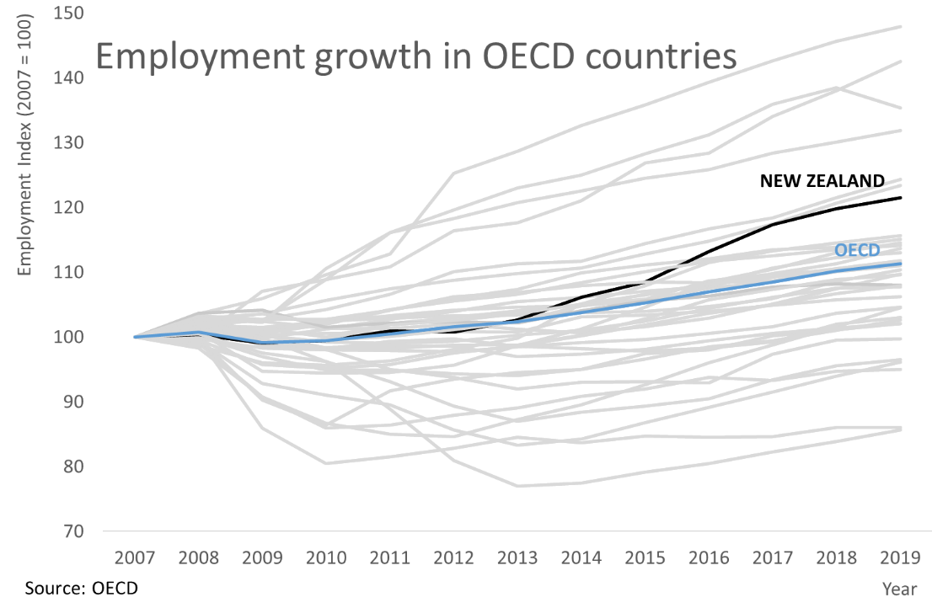

# Annex Two: Regional Population projections

**Medium projection: Year at 30 June 2018 – 2028 Percentage Change**

|  |  |  |  |  |  |  |  |  |  |  |
| --- | --- | --- | --- | --- | --- | --- | --- | --- | --- | --- |
| Region | [European or Other (including New Zealander)](http://nzdotstat.stats.govt.nz/OECDStat_Metadata/ShowMetadata.ashx?Dataset=TABLECODE7566&Coords=%5bETHNICITY%5d.%5bEUROTHER%5d&ShowOnWeb=true&Lang=en) – 15-19 years | [European or Other (including New Zealander)](http://nzdotstat.stats.govt.nz/OECDStat_Metadata/ShowMetadata.ashx?Dataset=TABLECODE7566&Coords=%5bETHNICITY%5d.%5bEUROTHER%5d&ShowOnWeb=true&Lang=en) – 20-24 years | Māori - 15-19 years | Māori – 20-24 years | Asian 15-19 years | Asian 20-24 years | Pacific 15-19 years | Pacific 20-24 years | Total population – 15-19 years | Total population – 20-24 years |
| Northland region | 17.50% | -14.43% | 25.26% | 18.32% | 58.33% | 25.00% | 39.53% | 32.81% | 12.74% | -8.45% |
| Auckland region | 11.53% | -4.97% | 16.61% | 8.66% | 23.04% | -10.55% | 9.71% | 7.04% | 8.84% | -6.98% |
| Waikato region | 8.92% | -5.21% | 27.18% | 19.37% | 51.94% | 9.21% | 47.20% | 28.18% | 11.86% | -7.98% |
| Bay of Plenty region | 3.09% | -4.82% | 20.00% | 23.02% | 48.08% | 16.45% | 52.21% | 41.30% | 6.58% | -7.94% |
| Gisborne region | 15.00% | -20.41% | 11.16% | 20.65% | 87.50% | 37.50% | 30.77% | 57.89% | 4.78% | -4.58% |
| Hawke's Bay region | 4.43% | -12.85% | 21.88% | 15.70% | 61.82% | 36.73% | 36.56% | 33.33% | 6.74% | -9.67% |
| Taranaki region | 16.45% | -5.73% | 27.03% | 24.73% | 80.00% | 29.63% | 50.00% | 35.00% | 14.07% | -4.06% |
| Manawatu-Wanganui region | 3.10% | -12.65% | 22.12% | 10.93% | 30.22% | 12.58% | 53.54% | 28.57% | 4.33% | -11.71% |
| Wellington region | 0.90% | -4.68% | 25.30% | 11.45% | 38.02% | -2.21% | 23.15% | 7.62% | 3.89% | -7.21% |
| Tasman region | 1.06% | 0.49% | 0.00% | 18.92% | 60.00% | 52.94% | 50.00% | 63.64% | -0.33% | 1.83% |
| Nelson region | 11.70% | 6.02% | 22.22% | 24.00% | 44.44% | 36.00% | 39.13% | 28.57% | 10.79% | 5.10% |
| Marlborough region | 16.42% | -12.72% | 50.00% | 8.33% | 90.00% | 75.00% | 70.83% | 52.63% | 17.26% | -7.65% |
| West Coast region | 17.33% | -20.92% | 16.22% | 0.00% | 54.55% | 36.36% | 55.56% | 100.00% | 12.65% | -9.93% |
| Canterbury region | 10.08% | -3.34% | 35.65% | 22.24% | 39.68% | 20.52% | 48.43% | 25.16% | 10.86% | -6.06% |
| Otago region | 6.71% | -4.90% | 31.84% | 14.15% | 4.10% | -11.69% | 48.08% | 18.33% | 6.98% | -7.08% |
| Southland region | 7.16% | -8.78% | 19.72% | 25.86% | 64.29% | 20.00% | 39.29% | 63.16% | 8.57% | -8.54% |
| Area outside region | 25.00% | 125.00% | 50.00% | 100.00% | - | - | - | - | 20.00% | 66.67% |
| [Total, North Island regions](http://nzdotstat.stats.govt.nz/OECDStat_Metadata/ShowMetadata.ashx?Dataset=TABLECODE7566&Coords=%5bAREA%5d.%5bNIRC%5d&ShowOnWeb=true&Lang=en) | 8.11% | -6.37% | 21.45% | 14.60% | 29.68% | -5.95% | 17.96% | 11.27% | 8.24% | -7.55% |
| [Total, South Island regions](http://nzdotstat.stats.govt.nz/OECDStat_Metadata/ShowMetadata.ashx?Dataset=TABLECODE7566&Coords=%5bAREA%5d.%5bSIRC%5d&ShowOnWeb=true&Lang=en) | 9.03% | -4.31% | 30.61% | 19.66% | 32.35% | 10.59% | 48.18% | 29.21% | 9.51% | -6.06% |

**Medium projection: Year at 30 June 2018 – 2028 Numerical Change**

|  |  |  |  |  |  |  |  |  |  |  |
| --- | --- | --- | --- | --- | --- | --- | --- | --- | --- | --- |
| Region | [European or Other (including New Zealander)](http://nzdotstat.stats.govt.nz/OECDStat_Metadata/ShowMetadata.ashx?Dataset=TABLECODE7566&Coords=%5bETHNICITY%5d.%5bEUROTHER%5d&ShowOnWeb=true&Lang=en) – 15-19 years | [European or Other (including New Zealander)](http://nzdotstat.stats.govt.nz/OECDStat_Metadata/ShowMetadata.ashx?Dataset=TABLECODE7566&Coords=%5bETHNICITY%5d.%5bEUROTHER%5d&ShowOnWeb=true&Lang=en) – 20-24 years | Māori - 15-19 years | Māori – 20-24 years | Asian 15-19 years | Asian 20-24 years | Pacific 15-19 years | Pacific 20-24 years | Total population – 15-19 years | Total population – 20-24 years |
| Northland region | 1230 | -830 | 1440 | 830 | 280 | 120 | 340 | 210 | 1380 | -770 |
| Auckland region | 6540 | -3310 | 2970 | 1640 | 6070 | -4350 | 2420 | 1750 | 9650 | -9730 |
| Waikato region | 2000 | -1180 | 2840 | 1830 | 1470 | 360 | 1010 | 510 | 3700 | -2690 |
| Bay of Plenty region | 410 | -540 | 1690 | 1510 | 750 | 250 | 590 | 380 | 1270 | -1400 |
| Gisborne region | 240 | -300 | 270 | 380 | 70 | 30 | 80 | 110 | 160 | -130 |
| Hawke's Bay region | 330 | -790 | 930 | 570 | 340 | 180 | 340 | 250 | 710 | -860 |
| Taranaki region | 990 | -300 | 600 | 460 | 240 | 80 | 130 | 70 | 1010 | -250 |
| Manawatu-Wanganui region | 390 | -1700 | 1170 | 550 | 420 | 190 | 530 | 260 | 700 | -2060 |
| Wellington region | 230 | -1420 | 1690 | 780 | 1380 | -110 | 970 | 310 | 1310 | -2950 |
| Tasman region | 30 | 10 | 0 | 70 | 60 | 45 | 35 | 35 | -10 | 40 |
| Nelson region | 310 | 130 | 120 | 120 | 120 | 90 | 45 | 30 | 340 | 130 |
| Marlborough region | 330 | -220 | 250 | 40 | 90 | 60 | 85 | 50 | 390 | -150 |
| West Coast region | 260 | -320 | 60 | 0 | 30 | 20 | 25 | 30 | 210 | -150 |
| Canterbury region | 3360 | -1250 | 1900 | 1110 | 1730 | 1030 | 770 | 400 | 4310 | -2800 |
| Otago region | 980 | -840 | 640 | 290 | 80 | -360 | 250 | 110 | 1210 | -1500 |
| Southland region | 370 | -440 | 280 | 300 | 180 | 60 | 110 | 120 | 510 | -490 |
| Area outside region | 5 | 25 | 10 | 15 | 0 | 0 | 5 | 5 | 5 | 20 |
| [Total, North Island regions](http://nzdotstat.stats.govt.nz/OECDStat_Metadata/ShowMetadata.ashx?Dataset=TABLECODE7566&Coords=%5bAREA%5d.%5bNIRC%5d&ShowOnWeb=true&Lang=en) | 12370 | -10370 | 13590 | 8560 | 11030 | -3240 | 6410 | 3870 | 19890 | -20850 |
| [Total, South Island regions](http://nzdotstat.stats.govt.nz/OECDStat_Metadata/ShowMetadata.ashx?Dataset=TABLECODE7566&Coords=%5bAREA%5d.%5bSIRC%5d&ShowOnWeb=true&Lang=en) | 5610 | -2890 | 3260 | 1940 | 2300 | 940 | 1320 | 780 | 6950 | -4930 |

1. PISA measures students’ competencies to participate actively in situations that require maths and reading skills.
2. Students who move school twice or more over the period from the 1st of March to the 1st of November.
3. Productivity Commission (2015), *More effective social services*. <https://www.productivity.govt.nz/assets/Documents/6e7cb6e142/social-services-final-report-summary.pdf>
4. Youth Service supports young people aged 16 to 17 years and parents aged between 16 and 19 most at risk of long-term benefit receipt into education, training or work-based learning.
5. Some funding was reallocated as part of Budget 2021. The total amount of funding available to the MTTF is now $30 million
6. Using StatsNZ medium scenario population projections, which projects the factors that influence total population, including births, deaths and migration.
7. Prime Ministers Business Advisory Council (2019). *A Future that Works: Harnessing automation for a more productive and skilled New Zealand.* 